Northstar Learning – RHIT Exam Prep

Go to www.northstarlearning.com

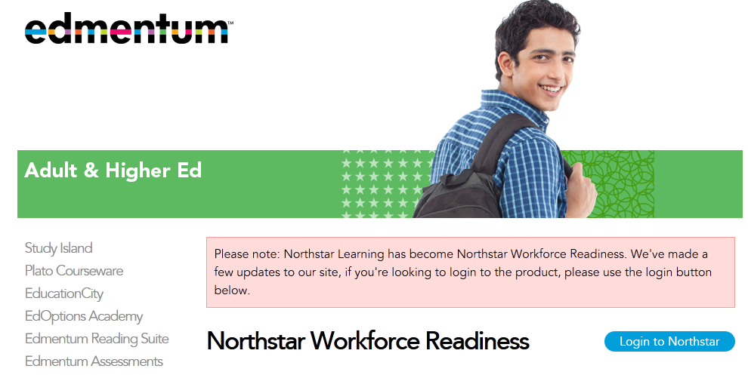

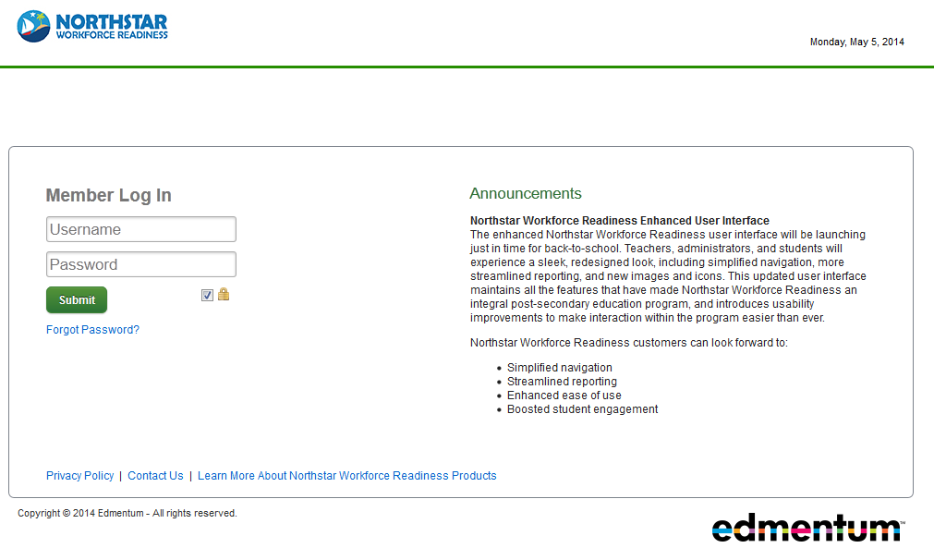

Log In: first initial + last name @hinds
Password: hinds
Example: mmcguffee@hinds

The due dates for your Northstar assignments are listed below. In addition to using the Northstar Learning RHIT Exam Prep, we will also be using the AHIMA RHIT Exam Prep book and online software.

