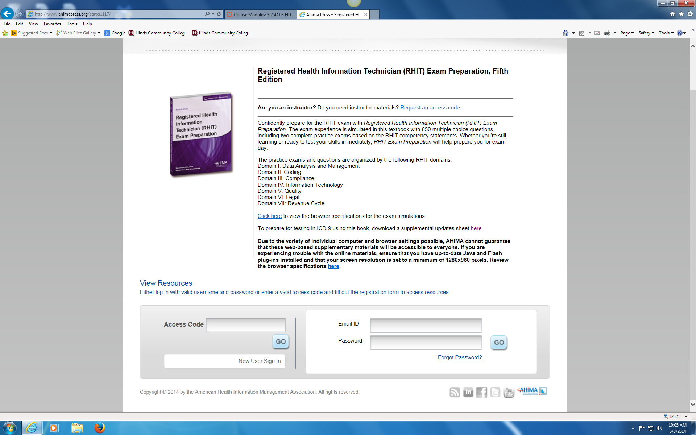

Enter your access code located in the front of your book. You will also have to set up your new user sign in.

