Microbiology Lab
Helpful Terms

- Ubiquitous- means microorganisms are found almost everywhere. They can be found in your body, dirt, on desks, money, in water, etc.
- Sterile- when there are NO microorganisms present. Some of your organs in your body are considered to be sterile; heart, lungs, bones, blood. It is when organisms get into these sterile areas that people become sick or get an infection.
- Nonpathogenic- organisms that do not cause infection
- Pathogens- organisms that do cause infection
- Commensal (Normal Microbiota)- organisms that live either on our skin or in the mucous membranes of our gastrointestinal tract, genitourinary tracts, or respiratory tracts. They are SUPPOSED to be there and as long as they stay where they belong, they do not cause us harm.
- Opportunistic pathogens- Normal microbiota that move to other parts of our body and cause infections. They take the OPPORTUNITY to grow. EX: E. coli is a normal microbiota of our intestines. If it moves to our urinary tract it is the #1 cause of Urinary Tract Infections(UTI).
- Media: is an AGAR plate. Agar is a gelatin substance that has a solid surface to it. The media include nutrients that encourage the growth of the organisms. The media you would use for this experiment is called Nutrient Agar. The reason we use this specific agar is because it is general purpose meaning it will grow just about anything.
  - General Purpose- The media will grow just about anything. Bacteria and fungus.
  - Selective- Has substances in it that will allow growth of certain organisms but also has substances that inhibit the growth of certain organisms making it selective for what it grows.
  - Differential- a type of selective media that shows a Visual difference between different organisms. Usually color difference but can be cracks, bubbles, clots or black participate.
- Inoculate means you’re introducing the organism to an area where it has all of the nutrients it needs to grow.
- Different types of growth:
  - Colonies- a VISIBLE mass of cells on an agar plate. This lets you know growth is present. They come in all sizes, shapes and colors.

    - Bacterial colonies- are typically smaller, round, shiny, and smooth.
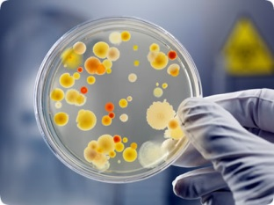

    - Fungal colonies- are typically larger, irregular border, rough, and fluffy looking. Think about bread mold.
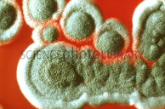

  - Turbidity- cloudiness. This is what growth in a liquid media looks like. Notice in the picture the first tube is extremely cloudy and then you have varying degrees of cloudiness. Very cloudy= lots of growth. Less cloudy=less growth.
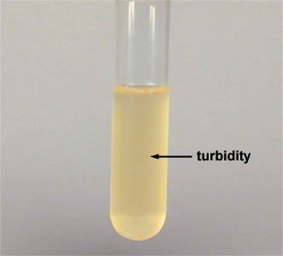

- Autoclave- the device used for steam sterilization. This is where we put all material that has growth on it. If it works correctly it will completely STERILIZE the material.

