Staining
Even with the use of a microscopes, the majority of cells are devoid of color and appear colorless or transparent when viewed through a microscope. This makes it difficult to locate the identifiable internal structures. For this reason, biological stains are used to facilitate visualization. Stains increase the contrast between the microorganism and the surrounding tissue (or slide). Bacteria are typically negatively charged so positively charged dyes (such as crystal violet) are used to stain the cells
Different stains and staining methods are used depending on what organisms are being studied. To begin the staining process, a bacterial sample is placed on a slide and then “fixed” to the slide by gentle heating.
Fixing the sample accomplishes three things:
1.It kills the bacteria.
2.It securely attaches the bacteria to the slide so that the sample is not lost during the staining procedure.
3.It makes the bacteria easier to stain.

You can have a positive(cationic stain) or a negative(anionic stain). Chromophores are the colored portion of the dye.
In a positive stain, chromophores are positive.
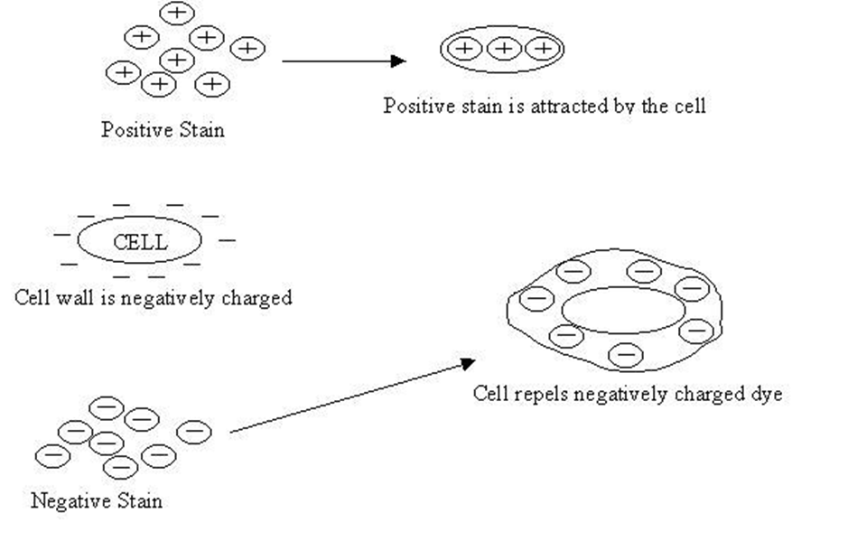
Since the bacterial cell is NEGATIVE, the chromophores repel to the background coloring the background and leaving the cell colorless.
Since the bacterial cell is NEGATIVE, the chromophores attach to the cell and color the cell leaving the background colorless.
In a negative stain, chromophores are negative.

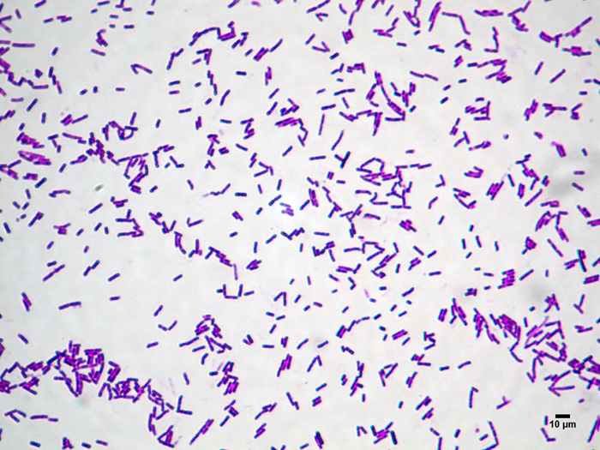
POSTIVE STAIN

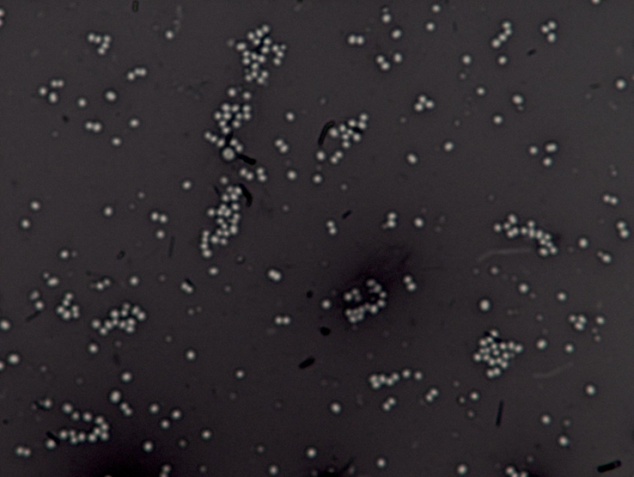
Negative Stain

Negative Staining
Negative staining provides a more detailed assessment of a microbe's morphology than simple staining does because the background (rather than the microbe) is stained. This prevents the staining procedure from causing any distortion to the microbe's ultrastructure. It also makes the outline of the cells highly visible. Bacterial cells are negatively charged, as are some stains (such as nigrosin). Negative staining works because “like” charges repel each

Simple and Differential Staining
Some bacterial stains are simple, meaning only one type of stain is used. Simple stains are typically easy to perform and provide basic information about morphology. However, simple stains can't typically identify the type of bacteria in the sample. Differential stains are often used to identify bacteria. Differential stains contain two or more different stains and can distinguish between different bacteria through their chemical or structural features.

Gram Stain- a type of differential stain
Gram positive bacteria and Gram negative bacteria differ in how their cell walls of composed. The major differences are:
Gram + Gram –
- Teichoic acid Lipopolysaccharides(outer membrane)
- Thick layer of peptidoglycan Thin layer of peptidoglycan
*The outer membrane is very important in a gram stain.
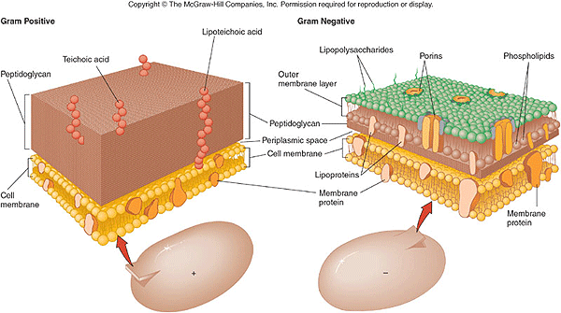

Note: Review the directions for signing in to the Student Portal at the beginning of this manual if uncertain how to access this information.

Procedure
1.Log into your eScience Student Portal account and choose the Microbiology Lab kit under My Lab Kits.
2. Under Online Learning Tools, choose Culturing and Structure.
3. Find the Gram Stain Procedure. It is almost at the end of the page.
4. Click Next and watch the video. Make sure to answer the questions at the end and also take notes on the procedure.

