LAWN!

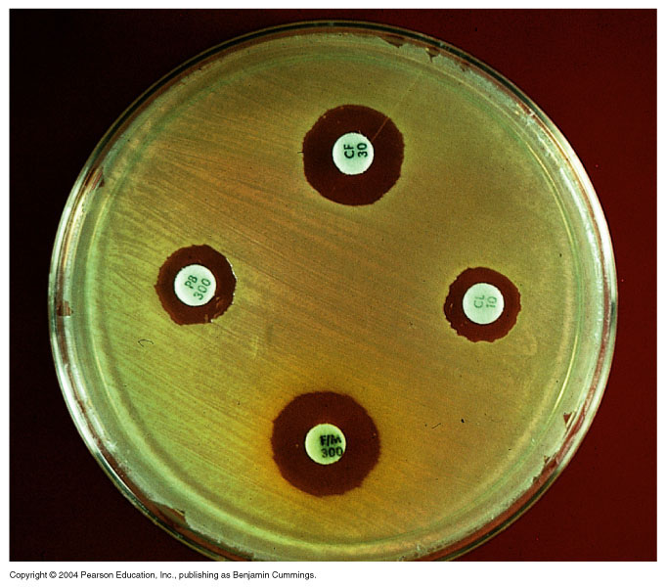

Zones of inhibition! Measure across the filter paper, from one side of the zone to the other side of the zone. In millimeters.