Microsoft Office 2013 Illustrated
Unit H: Using Complex Formulas, Functions, and Tables
Table of Contents
Concepts Review 2
Skills Review 3
Independent Challenge 1 4
Independent Challenge 2 5
Independent Challenge 3 6
Independent Challenge 4: Explore 7
Visual Workshop 8

Unit H: Using Complex Formulas, Functions, and Tables

Concepts Review

Screen Labeling | Matching Items | Multiple Choice
1. Filter list arrow | 8.a | 13.c
2. Table | 9. b | 14.b
3. Quick Analysis gallery | 10. e | 15.d
4. Quick Analysis button  5. Total row in a table  6. Filter icon  7. Absolute cell reference in a formula | 11. d  12.c | 16.b  17.c  18.d  19.a

Skills Review
The filename for the completed workbook in this exercise is H-June Orders.xlsx. The completed solution file is shown here.

Estimated Completion Time: 20 minutes
Filename: H-June Orders.xlsx

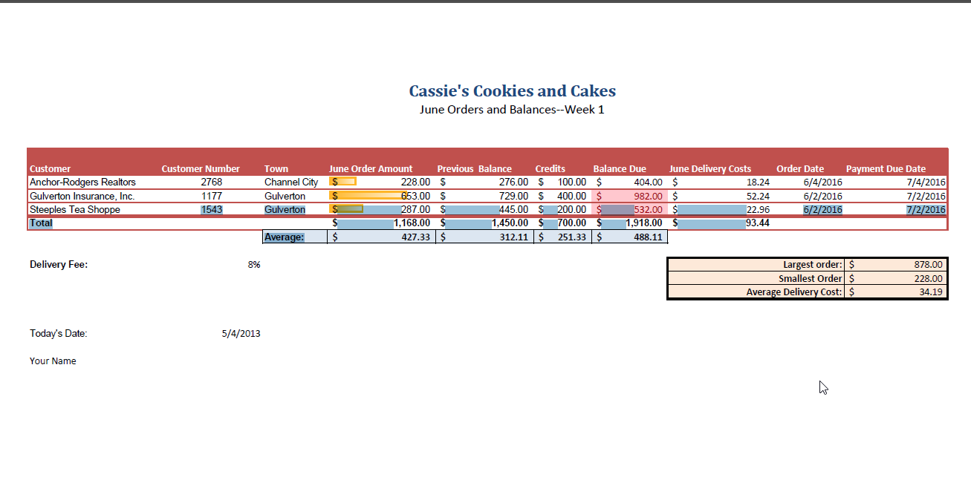

Independent Challenges

Because students may tackle the independent challenges in different ways, it is important to stress that some Independent Challenges have more than one correct solution.

Independent Challenge 1
Students modify an existing workbook to create a quarterly sales analysis for each state in a sales region for H-Red Condor Q1 Sales.xlsx. Student’s solutions should match the one shown below.

Estimated completion time: 20 minutes
Filename: H-Red Condor Q1 Sales.xlsx

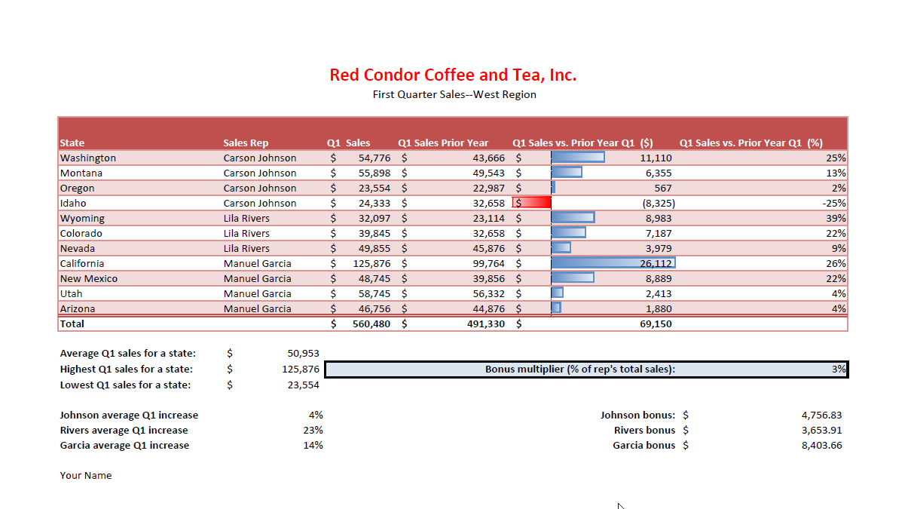

Independent Challenge 2
In this exercise, students modify an existing workbook to create a final worksheet that analyzes sales for Plaxco-Perez Windows and Doors, Inc. for the month of October. Student solutions should match the solution shown below.

Estimated completion time: 20 minutes
Filename: H-October Sales Rep Report.xlsx
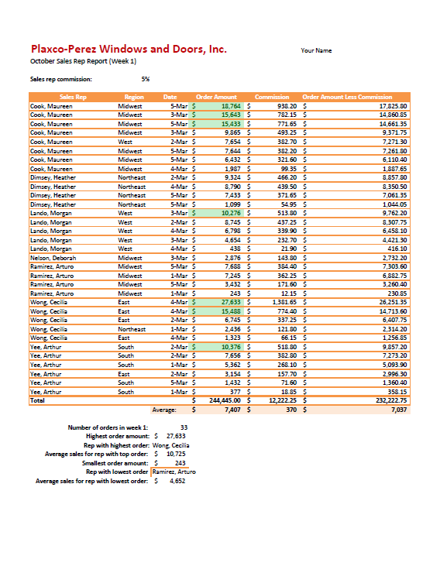

Independent Challenge 3
In this Independent Challenge, students modify an existing worksheet that calculates profits for a catering business. Students use a complex formula to calculate the profit, then use functions to perform various other calculations. Student solutions will vary in formatting, but their values and formulas should match the ones shown in the solution figure below.

Estimated completion time: 20 minutes
Filename: H-Catering Profits.xlsx

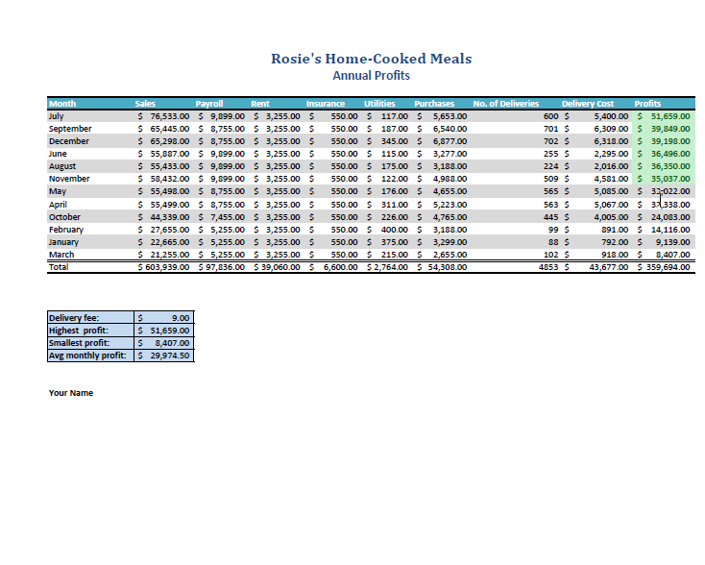

Independent Challenge 4: Explore
In this Independent Challenge, students download a template for calculating monthly payments for a car loan. The solution is shown below.

Estimated completion time: 20 minutes
Filename: H-Car Loan.xlsx—page 1

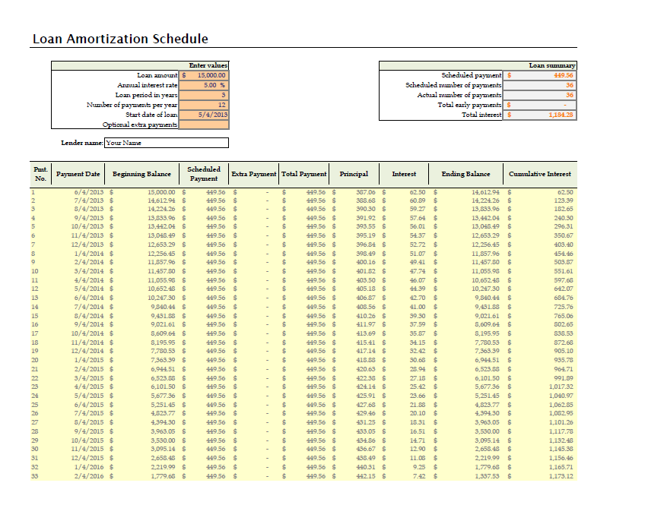

Filename: H-Car Loan.xlsx—page 2 (cropped)

Visual Workshop

In this exercise, students create the worksheet shown below using the skills learned in the unit. Solutions should match the figure below exactly.
What to look for:
- The range F5:F16 (Total Camper Fees) should include formulas that multiply the values in column C (No of Classes) by the values in column D (Camper Fee per Session) by the values in column E (No. of Campers)
- The range G5:G16 (Coach Cost) should include formulas that multiply the values in column C (No of Sessions) by the value in cell B19 (the Coach Fee). These formulas need to include B19 as an absolute cell reference.
- The range H5:H16 should include formulas that subtract column G from column F.
- Cell H19 should include a formula that calculates the Average amount in the range H5:H16
- Cell H20 should include a formula that calculates the Average amount in the range E5:E16
- The range A4:H16 needs to be converted to a table, then the table needs to be sorted by the Coach column in alphabetical order.
- The orientation is set to Landscape.

Estimated completion time: 20 minutes
Filename: H-Summer Camps Profitrs.xlsx

