Microsoft Office 2013 Illustrated
Unit E: Enhancing a Document
Table of Contents
Concepts Review 2
Skills Review 3
Independent Challenge 1 4
Independent Challenge 2 5
Independent Challenge 3 6
Independent Challenge 4: Explore 7
Visual Workshop 8

Unit E: Enhancing a Document

Concepts Review

Screen Labeling | Matching Items | Multiple Choice
1. Tab selector button with left tab icon displayed | 11. c | 16. c
2. Italic button | 12. a | 17. a
3. Font list arrow | 13. b | 18. b
4. Font Size list arrow | 14. e | 19. b
5. Text Effects button | 15. d | 20.b
6. Font Color button
7. Center button
8. Bullets button
9. Justify buttonry
10. Styles gallery

Skills Review
The filename for the completed document in this exercise is E-Songwriting Contest.docx. The completed solution file is shown here.

Filename: E-Songwriting Contest.docx
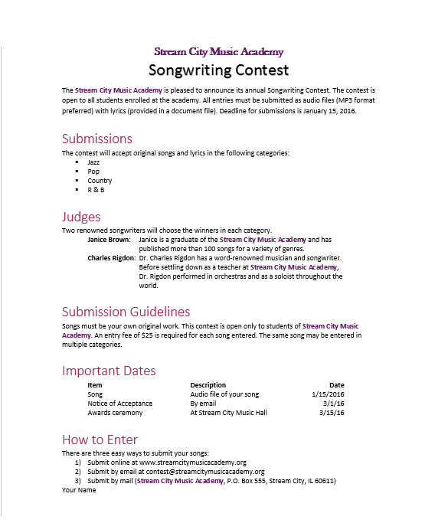

Independent Challenges

Because students may tackle the independent challenges in different ways, it is important to stress that for some Independent Challenges there is not just one correct solution.

Independent Challenge 1
Students open an existing document containing information about the East Riverton Recreation Center for the month of September and format it according to specific instructions. Students’ solutions should match the one shown below. (Note: the margins are cut off below; the margins should be set to default settings of 1” at top/bottom/left/right.)

Filename: E-September Classes.docx
Estimated Completion Time: 20 minutes

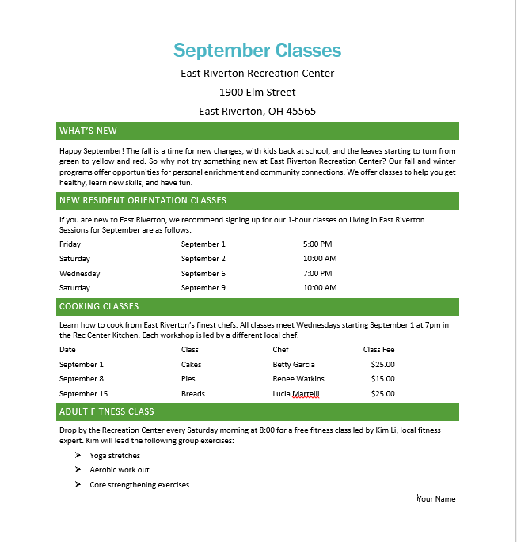

Independent Challenge 2
In this exercise, students format an existing unformatted document that contains information about biking tours. Students need to use their best judgment to format different parts of the document so that that the information is attractively laid out and easy to understand. Look for the following in their solutions:
- Company name and address should be center-aligned and should be formatted with fonts and styles to make it stand out
- Heading 1 style should be applied to the text About Captain Mike’s Biking Adventure Tours and Summer 2016 Biking Tours and All Adventures Include.
- Paragraph below About Captain Mike’s Biking Adventure Tours should be justified, and line spacing for this paragraph should be set at 1.15.
- The Casual style set should be applied to the entire document.
- Margins should have the preset Narrow setting applied.
- Tab stops for the last four paragraphs of text below Summer 2013 Walking Tours should be set at the 2” mark on the ruler, and these paragraphs should also have a hanging indent at the 2” mark on the ruler.
- The Strong style should be applied to the text Bavaria: Tuscany: Normand:; and Scotland:.
- The last four lines in the document should be formatted as a bulleted list,
- The student’s name should appear as the last line of the document and should be centered.

Estimated completion time: 20 minutes

Filename: E-Summer Biking Tours (One possible solution is shown below.)

Independent Challenge 3
In this Independent Challenge, students use their creativity and formatting skills to create a Day of Beauty gift certificate for a promotion at a day spa. Solutions will vary from student to student. One possible solution is shown below.
Look for the following in each solution:
- Text in the document should be formatted attractively with different fonts, styles, font sizes, and effects that make it effective.
- Some text on the certificate should be formatted as a bulleted list
- Margins should be adjusted to different settings from the default
- Final document should be printed in landscape orientation (a hint in step d explains how to do this)
- Student names should appear somewhere on the certificate

Estimated completion time: 20 minutes

Filename: E-Spa Gift Certificate.docx

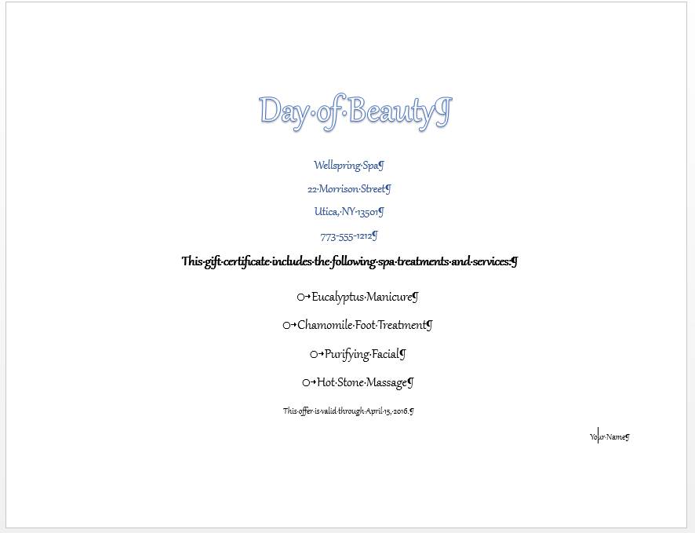

Independent Challenge 4: Explore
In this exercise, students create a menu for an ice cream business. Students will explore using some new skills related to the lesson material:
- Applying leader lines to tabbed items
- Formatting text into multiple colunns
- Applying a font style set

Filename: E-Ice Cream Flavors.docx
Estimated completion time: 30 minutes
Solution is shown below:

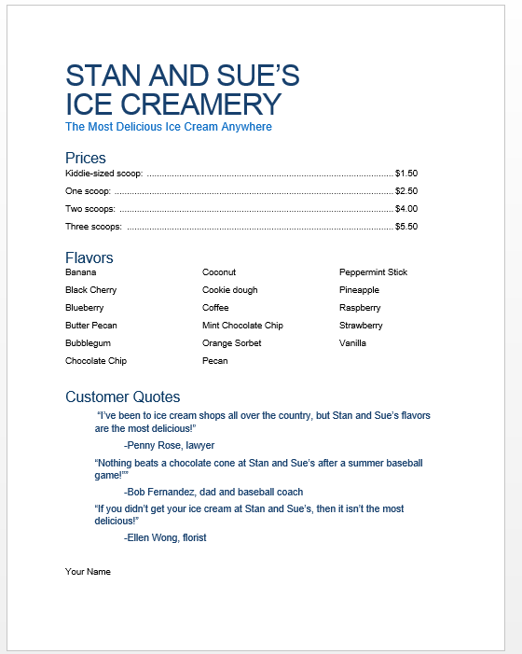

Visual Workshop

In this exercise, students format an existing document so that it appears as shown below. All solutions should match the one shown below Here’s what to look for in students’ solutions:
- Students need to use Calibri (Light) point for the restaurant name at the top of the menu, then apply the Title style to it.
- Students need to apply the Heading 1 style to each food category on the menu and the Intense Emphasis style to each menu item.
- Descriptions below the menu items should be indented at the ¼” mark.
- Right tab stops for the menu item prices should be set just to the left of the 5 ½” mark on the ruler.
- A left tab stops for the kids menu items should be set at the 2” mark on the ruler. There should also be a right tab stop at the 51/2”mark on the ruler for the kids menu items
- Students need to apply the Lines(Simple) style set to the document.
- Students need to change the color scheme of the document to Red Orange.
- Students’ names should be left aligned at the bottom of the document

Estimated time to complete: 30 minutes
Filename: E-Burger Menu.docx

