Microsoft Office 2013 Illustrated
Unit K Working with Data
Table of Contents
Concepts Review 2
Skills Review 3
Independent Challenge 1 8
Independent Challenge 2 11
Independent Challenge 3 13
Independent Challenge 4: Explore 14
Visual Workshop 15

Unit K: Working with Data

Concepts Review

Screen Labeling | Matching Items | Multiple Choice
1. Sales Reps table field list | 7. d | 13. d
2. one-to-many relationship line | 8. f | 14. c
3. Query design grid | 9. a | 15. a
4 Sort cell for YTD Orders field | 10. c | 16. b
5. Customers table field list | 11.e | 17. c
6. State field in Customers table field list | 12. b | 18. a

Skills Review
The filename for the completed database in this exercise is K-Poster Business.accdb. The completed solution file contains the objects shown in the Navigation pane below:

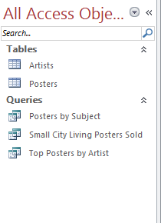

All objects are shown below. Students also apply filters and sort records in Datasheet view; those results are shown below, too.

Filename: K-Poster Business.accdb
Estimated completion time: 30-40 minutes

Answers to Questions in Skills Review:
2b.Product ID of first record when table is sorted by Poster Name in ascending order: 11253
Poster ID when sorted in descending order by Poster Name: 11243
2d. Poster Name: Brooklyn Bridge (when sorted by Amount Sold in the order of largest to smallest)
Poster name: UTurn (when sorted by Subject field in descending order).

2e. Shown below is the Posters table in Datasheet view after sorting first by the Amount Sold field in descending order, and then by Subject field in descending order. The students name should be in the Poster ID field for the first record (for the Poster “U-Turn”) in the sorted table, as shown below:
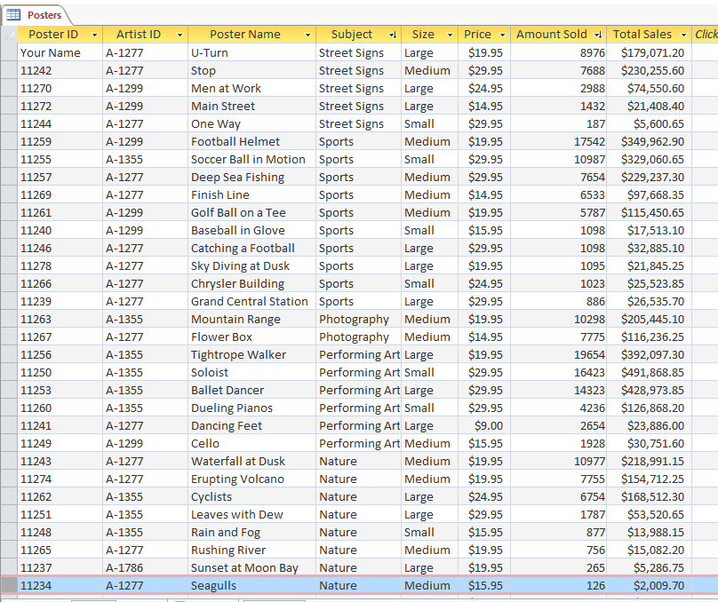

3a, Posters table with filter applied (after Step 3a) There are 9 records (containing “Nature” in the Subject field) with the filter applied:
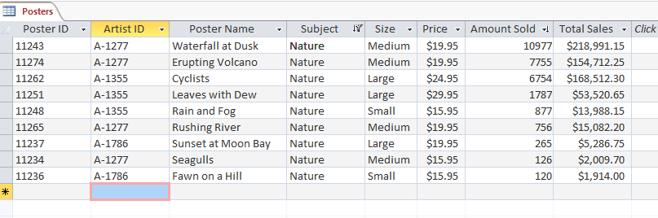

3c and 3d. Shown below is the Posters table with Number filter applied (after step 3c and 3d). There are 11 records showing. Poster name of the last record is London Bridge.
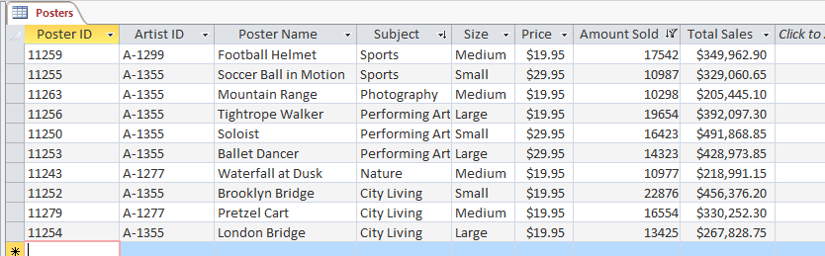

Posters by Subject query sorted by Subject field in ascending order (Step 4e)
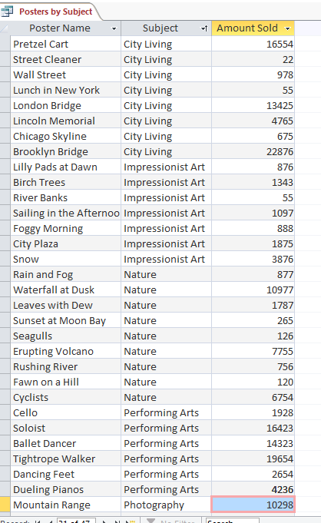

Small City Living Posters Sold query after Step 5e

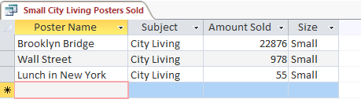
Top Posters by Artist (after step 7 h)
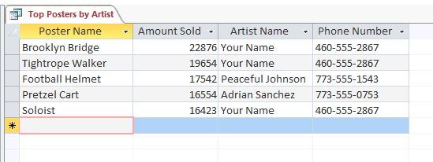

Posters table after adding calculated field in step 8d (in Datasheet view)

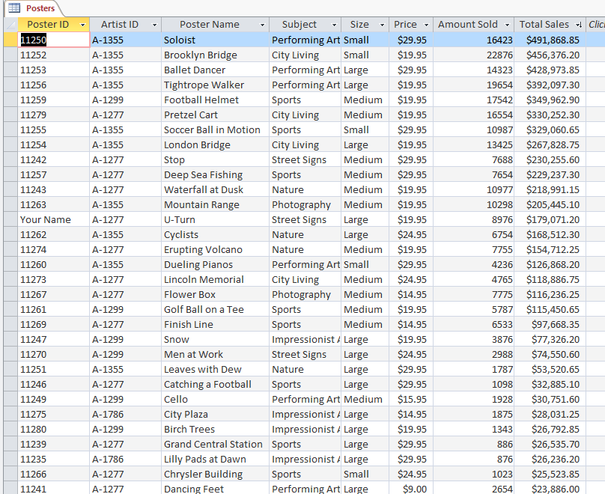

Independent Challenges

Because students may tackle the independent challenges in different ways, it is important to stress that for some Independent Challenges there is not just one correct solution.

Independent Challenge 1
Students work with an existing database that keeps track of campers and leaders at an arts camp.. Students sort and filter data in the tables and then create three queries, the results of which are shown below in Datasheet view.

Estimated completion time: 30 minutes
Filename: K-Arts Camp Camp.accdb

Filename: K-Arts Camp.accdb—Campers table sorted by Age and then Leader ID (both in ascending order)—after step c

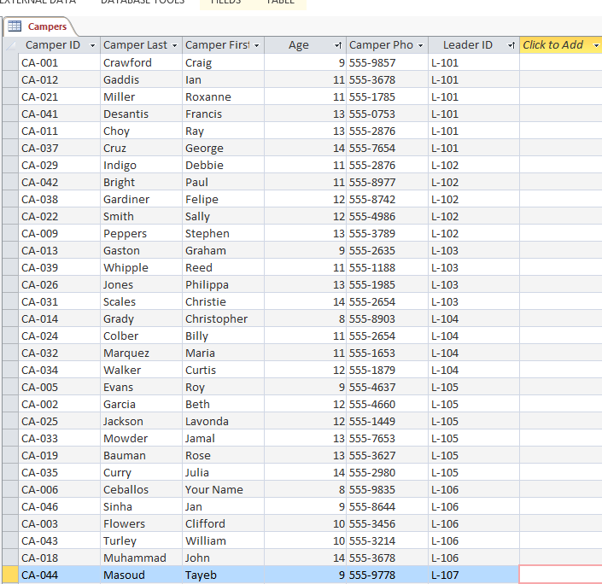
Filename: K-Arts Camp.accdbCampers table with filter applied to show only campers for Leader L-101 (Step d)
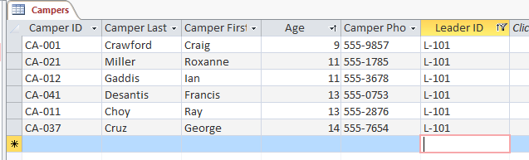

Filename: K-Arts Camp.accdb —Campers table with filter applied to show only campers for Counselor CO-110 who are age 12 or younger (step d)
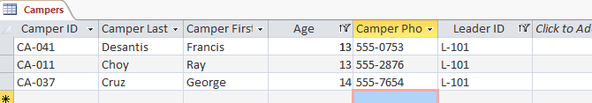

Filename: K-Arts Camp.accdb —Campers by Age query (step e)
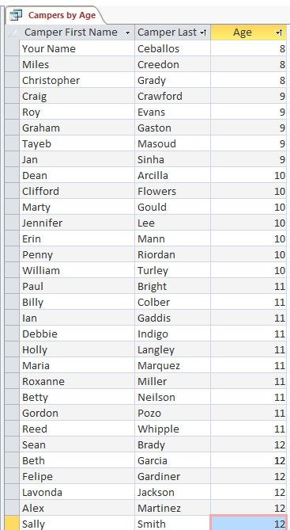

Filename: K-Arts Camp.accdb —L-102 Campers query (step f)
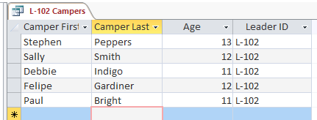

Filename: K-Arts Camp.accdb—Sculpture Campers query (step l)
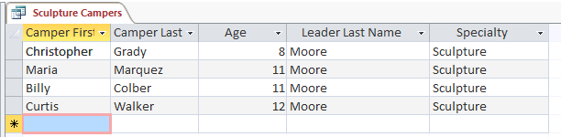

Independent Challenge 2
In this exercise, students work with a database for a fitness center that keeps track of students and classes. Students apply filters and create queries to answer questions. Students also set up one-to-many relationships between tables.

Estimated completion time: 20 minutes

Filename: K-Fitness Center—Students table with filter applied to show students taking class 3011, sorted in alphabetical order by Last field (Step b)

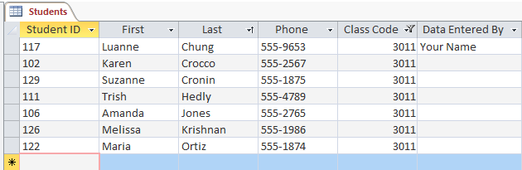

Filename: K-Fitness Center—Classes table with calculated field (Total Class Fee) added (sfter step d)
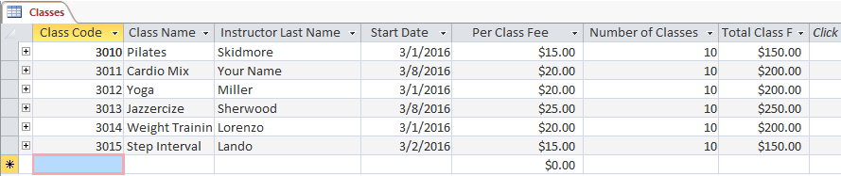

Filename: K-Fitness Center —Classes List query(after step g)
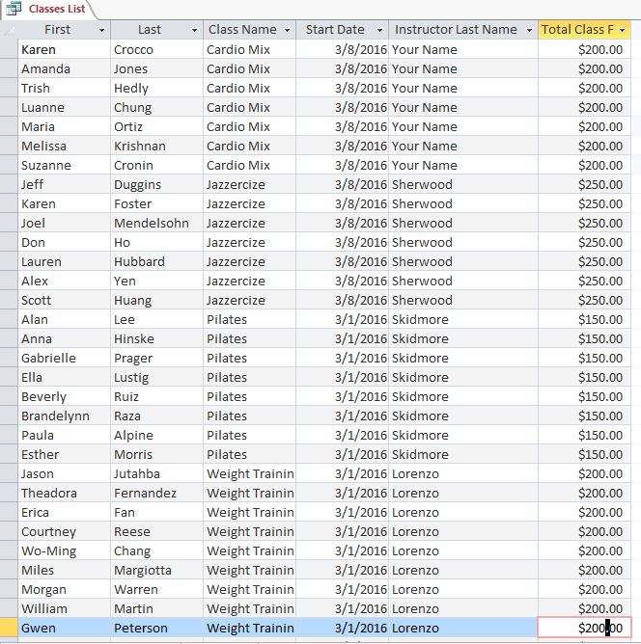

Filename: K-Fitness Center —Cardio Mix Class List query (after step i)

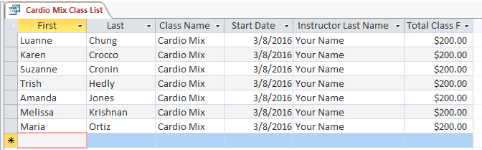

Independent Challenge 3
In this Independent Challenge, students set up one-to-many relationships between tables in the database K-Uncle Ruff’s Dog Care.accdb. Students then add a calculated field to one of the tables and create queries based on the related tables. All queries are shown below. Students’ query results should match the solutions exactly.

Estimated completion time: 30 minutes

Filename: K-Uncle Ruff’s Dog Care.accdb—Dog Walkers table (with Weekly Pay calculated field added)
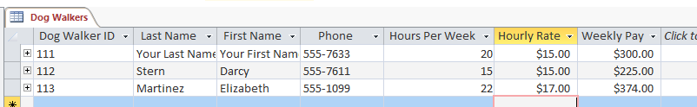

Filename: K-Uncle Ruff’s Dog Care.accdb —Monday Schedule
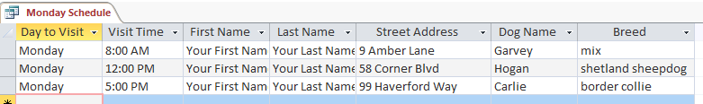

Filename: K-Uncle Ruff’s Dog Care.accdb —Darcy’s Dogs query

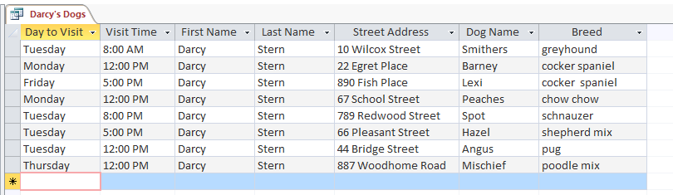

Filename: K-Uncle Ruff’s Dog Care.accdb —Martinez Weekly Service Notes query
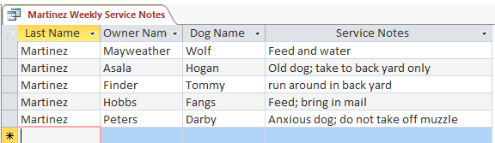

Independent Challenge 4: Explore
In this Independent Challenge, students open an existing database, rename it K-My Classes.accdb and enter data (based on their own class schedule) into the Classes, Instructors, and Homework tables. They then enter appropriate data—including attaching files and s and hyperlinks (new skills). Theyalso set up relationships between the tables. Finally, they create queries containing fields from the three related tables. Query results will vary between students because their data is unique to them; however, the fields from each query should match the results shown belenteow.

Estimated completion time: 30 minutes
Filename: K-My Classes.accdb

Filename: K-My Classes.accdb Instructors table (students’ data will vary; fields should match, though)
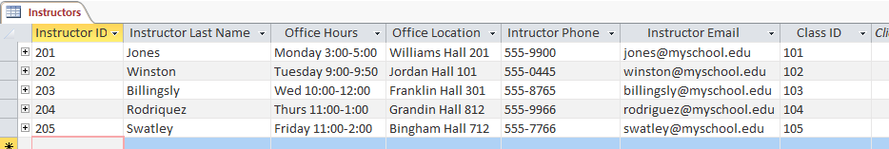

Filename: K-My Classes.accdb—Classes table (students’ data will vary; fields should match, though)

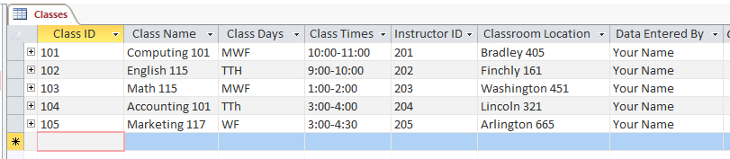

Filename: K-My Classes.accdb —Homework table (students’ data will vary; fields should match, though)
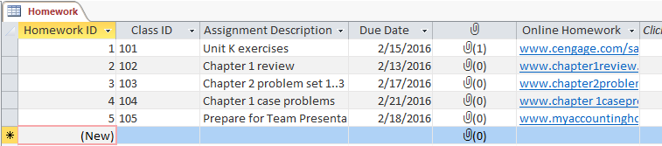

Visual Workshop

In this exercise, students open the Data File K-7, then save it as K-Dance Charity Event. They need to set up the relationships shown below:
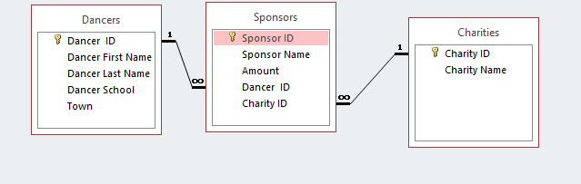
They also need to create the United Way Donations query shown on page 304 (and below). Make sure that students sort the data by the Amount field in descending order. In the query design grid for the United Way Donations query, “United Way” must be entered in the criteria cell for the Charity Name field. Students’ solutions need to match the solution shown below exactly.

Filename: K-Dance Charity Event.accdb—United Way Donations query
