Microsoft Office 2013 Illustrated
UNIT D Creating a Document
Table of Contents
Concepts Review 2
Skills Review 3
Independent Challenge 1 4
Independent Challenge 2 5
Independent Challenge 3 6
Independent Challenge 4: Explore 7
Visual Workshop 8

Unit D: Creating a Document

Concepts Review

Screen Labeling | Matching Items | Multiple Choice
1. Paste button | 11. a | 16. c
2. Copy button | 12. b | 17. a
3. Clipboard task pane | 13. d | 18. a
4. Bold button on Mini toolbar | 14. c | 19. b
5. Italic button | 15. e | 20. a
6. Font Size list arrow
7. Bullets button
8. Paragraph mark
9. Mini toolbar
10. Show/Hide ¶ button

Skills Review
The filename for the completed document in this exercise is D-Rosie’s Home-Cooked Meals.docx. The completed solution file is shown here. (Note: the margins are cut off below; the margins should be set to default settings of 1” at top/bottom/left/right.)

Filename: D-Rosie’s Home-Cooked Meals.docx

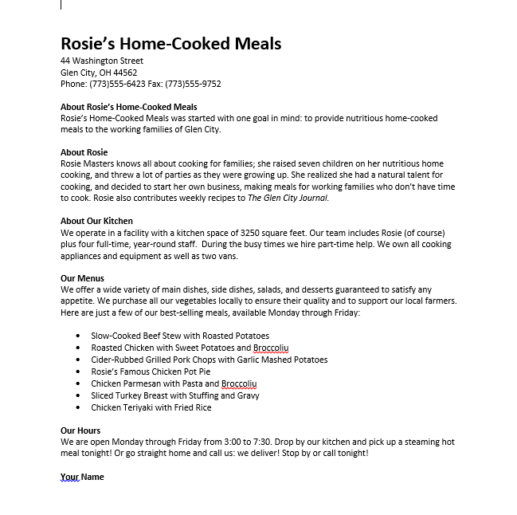
Independent Challenges

Because students may tackle the independent challenges in different ways, it is important to stress that for some Independent Challenges there is not just one correct solution.

Independent Challenge 1
Students modify an existing memo . Students use the information to edit the body of the memo themselves. They need to select the entire document first and apply the No Spacing style, so that the paragraphs are single spaced. They also make edits to the text in the document, add additional text, format some of the text in bold and italic, and format paragraphs as a bulleted list. They also use the Replace command to change the hotel name, and review/fix spelling and grammar errors. (Note: in the solution show below, the margins are cut off at the top and bottom; the margins should be set to default settings of 1” at top/bottom/left/right.)

Estimated completion time: 20 minutes

Filename: D-Sales Meeting Memo.docx

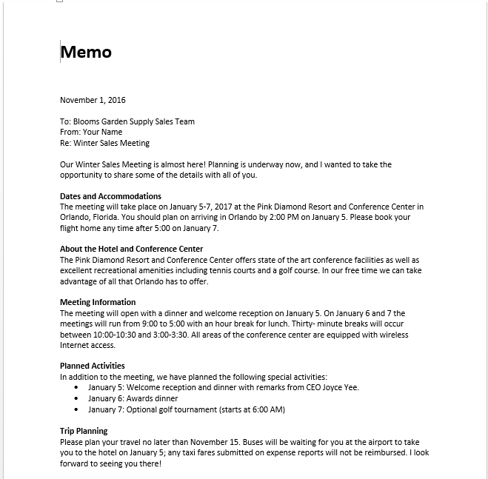

Independent Challenge 2
In this exercise, students modify an existing document to create a customer survey. Students will use editing skills learned in the lesson material to create and modify the survey. The name of the bakery shown at the top of the survey and in Questions1-4 will reflect each student’s first name, but otherwise the solutions should be consistent and look like the document pictured below.

Estimated completion time: 20 minutes

Filename: D-Bakery Survey.docx

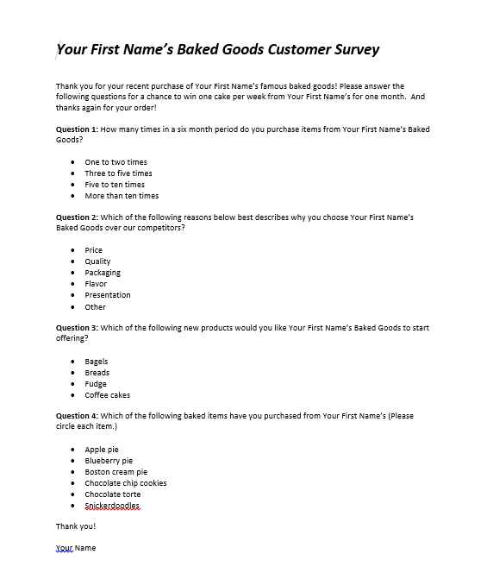

Independent Challenge 3

In this Independent Challenge, students modify an existing document to create a job description. Students will need to add new text, delete existing text, replace text with other text, and use the Mini toolbar to format text Student solutions should match the solution below exactly.

Estimated completion time: 20 minutes

Filename: D- Job Description.docx

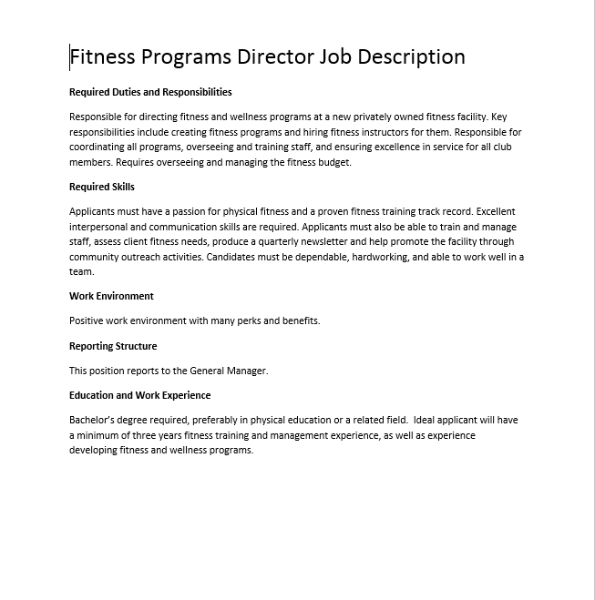

Independent Challenge 4: Explore
In this independent challenge, students explore new skills related to the lesson material, including creating a document from a template and using the translation tool to translate the document into French. They also have to write their own steps explaining how to copy text in Word—which helps reinforce their understanding of this important skill. Because the students will be writing their own steps, each student solution will be a little different. One possible solution is shown below. Note that the formatting of student solutions should match the graphic below.
Filename: D-Copying Text Instructions.docx

Estimated completion time: 20 minutes
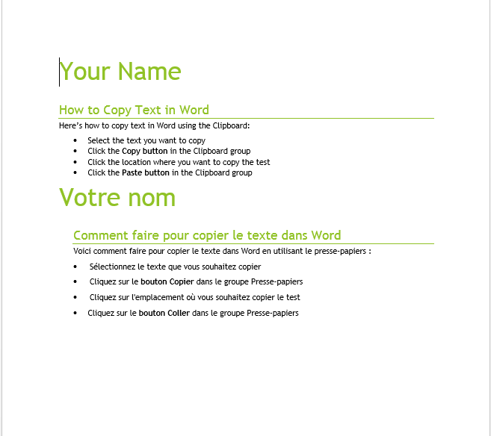

Visual Workshop

In this exercise, students create the file D-House Rental Ad.docx shown below. To create this document, students need to start from scratch, using a blank new document. Make sure they enter the text as shown. Note that they should also type their name below the last line of the document. All solutions should match the one shown below.

Filename: D-House Rental Ad.docx

Estimated completion time: 20 minutes

