Microsoft Office 2013 Illustrated
Unit I Working with Charts
Table of Contents
Concepts Review 2
Skills Review 3
Independent Challenges 4
Independent Challenge 1 4
6
Independent Challenge 2 7
Independent Challenge 3 8
Independent Challenge 4: Explore 9
Visual Workshop 11

Unit I: Working with Charts

Concepts Review

Screen Labeling | Matching Items | Multiple Choice
1. Chart title | 10. d | 14. d
2. Data marker | 11. a | 15. d
3. Y-axis title | 12. b | 16. a
4. Data series | 13. c | 17. a
5. X-axis title |  | 18. a
6. Legend
7. Chart Styles button
8. Chart Elements button
9. Sparklines

Skills Review
The filename for the completed workbook in this exercise is I-Solar Panel Sales.xls. The completed solution file is shown here.

Filename: I-Solar Panel Sales.xlsx—worksheet with chart (on Sheet1)
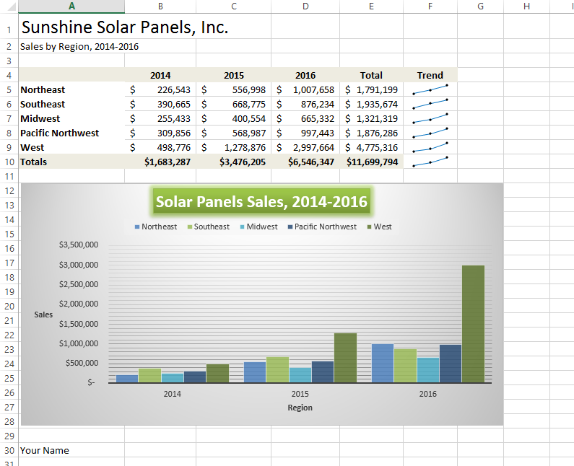
I-Solar Panels Sales .xlsx—Sales by Region chart sheet
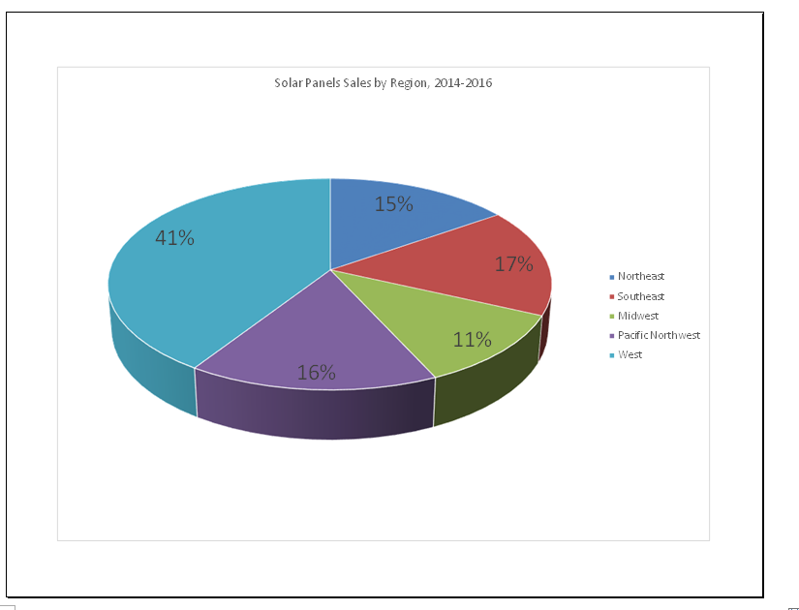

Independent Challenges

Because students may tackle the independent challenges in different ways, it is important to stress that some Independent Challenges have more than one correct solution.

Independent Challenge 1
Students create a chart based on the data in an existing worksheet to show the annual sales for a dog care business. Students also create a 2-D exploded pie chart based on the data in the worksheet and move it to a separate chart sheet. Students’ solutions data should match the worksheet and chart sheet shown below.

Estimated completion time: 20 minutes
Filename: I-Dog Care Monthly Revenue.xlsx

I-Dog Care Monthly Revenue.xlsx--worksheet with chart (on Sheet1)
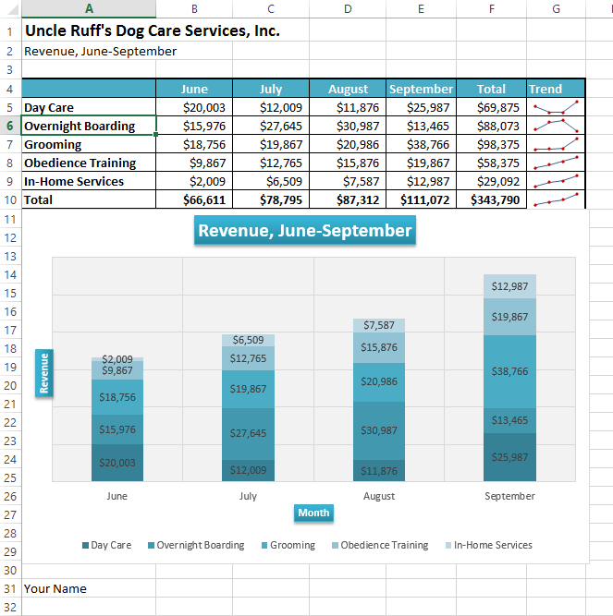

I-Dog Care Monthly Revenue.xlsx—Revenue by Service Type chart sheet

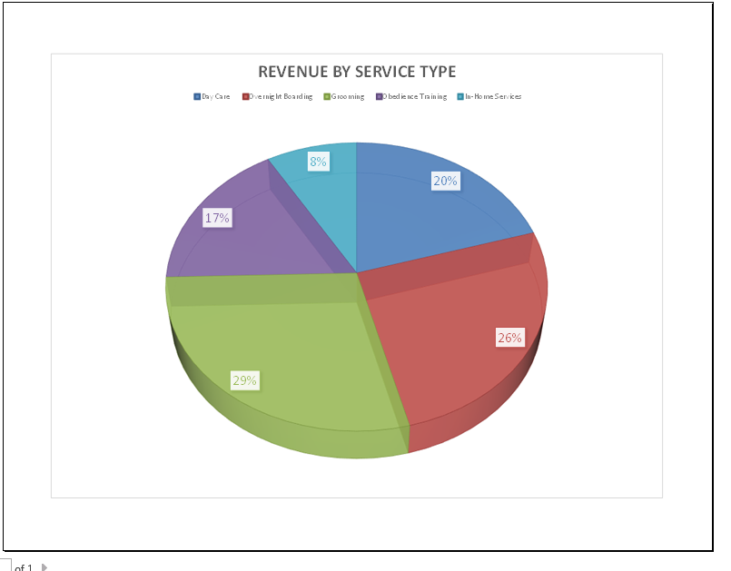

Independent Challenge 2
In this exercise, students modify an existing workbook to create a pie chart showing sales by product category at an online baked goods retailer for December. Student solutions should match the content of the solution shown below; but their formatting will vary.

Estimated completion time: 20 minutes

Filename: I-December Sales.xlsx
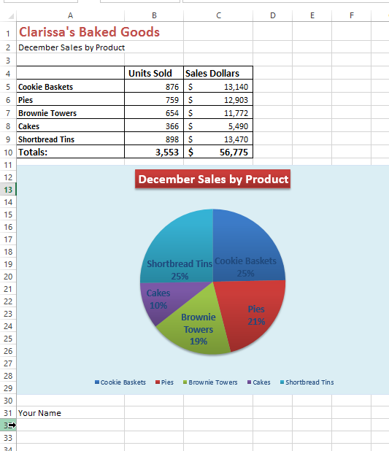

Independent Challenge 3
In this Independent Challenge, students create a 2-D line chart on a separate chart sheet that shows the categories of visitors who visited a zoo from March through July. Solutions will vary slightly, based on some formatting options they choose, but look for the following in every solution:

- Chart type should be 2D Line with Markers.
- Chart should be moved to a separate chart sheet named Zoo Visitors March-July.
- Layout 9 chart layout and chart style 9 should be applied.
- and be rotated. Chart should have an appropriate horizontal axis title.
- The chart title and axis titles should have a shape style applied to them. (Should be the same style for all three.) The chart title should appear as Zoo Visitors, March-July, and should have a shape style applied to it.
- The plot area should have a solid color fill applied to it with Olive Green, Accent 3, Lighter 80%
- Primary major horizontal gridlines should appear in the chart.
- Student name should also appear in cell A8 of the worksheet.

Estimated completion time: 20 minutes
Filename: I-Zoo Visitors.xlsx

I-Zoo Visitors.xlsx—(worksheet on Sheet1)
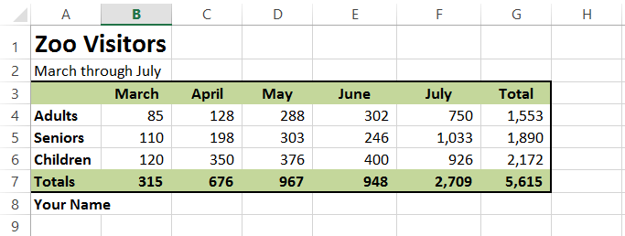

I-Zoo Visitors.xlsx—Zoo Visitors May-Sept chart sheet
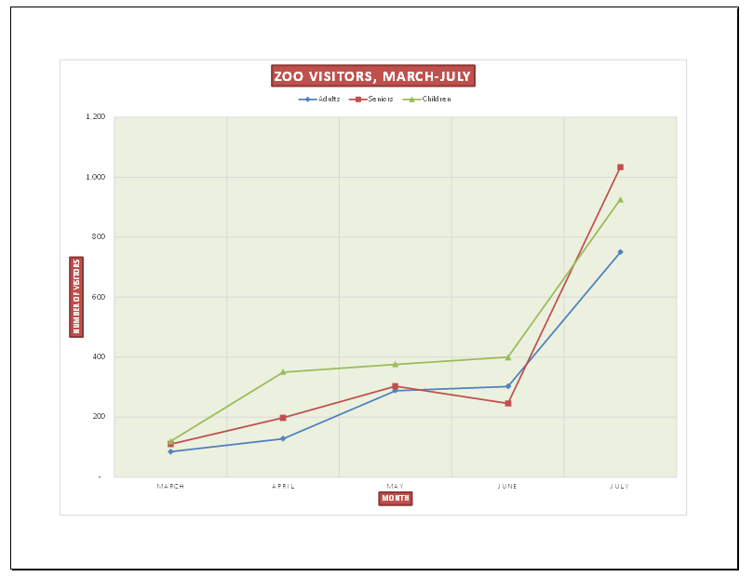

Independent Challenge 4: Explore
In this Independent Challenge, students create a personal budget for monthly expenses, based on a monthly income of $3000. Solutions will vary, based on the types of expenses and amounts that students enter. Check for the following in all solutions:

- The title My Monthly Expenses should be in cell A1. Student name should be in cell A2
- The worksheet should contain two columns. The first column label in A3 should be Expense and second column label in cell B3 should be Amount.
- Student worksheets should have the same labels shown in the solution below in the range A4:A13.
- Appropriate amounts for each expense should be entered in cells B4:B13. All expense amounts and total amount should be formatted as currency.
- Cell A14 should contain the label Total. Cell B14 should contain a formula that calculates the sum of all the expenses. Resulting value in this cell should equal $3000.
- Worksheet should contain a pie chart below the worksheet data. Students can choose any pie chart option they like, and can also apply any chart layout and style to the chart.
- Pie chart should have the title My Monthly Expenses.
- Worksheet should contain a clustered bar chart to the right of the worksheet data and above the pie chart. It should have the title My Monthly Expenses.

Filename: I-My Monthly Expenses.xlsx (One possible solution is shown below.)
Estimated completion time: 30 minutes

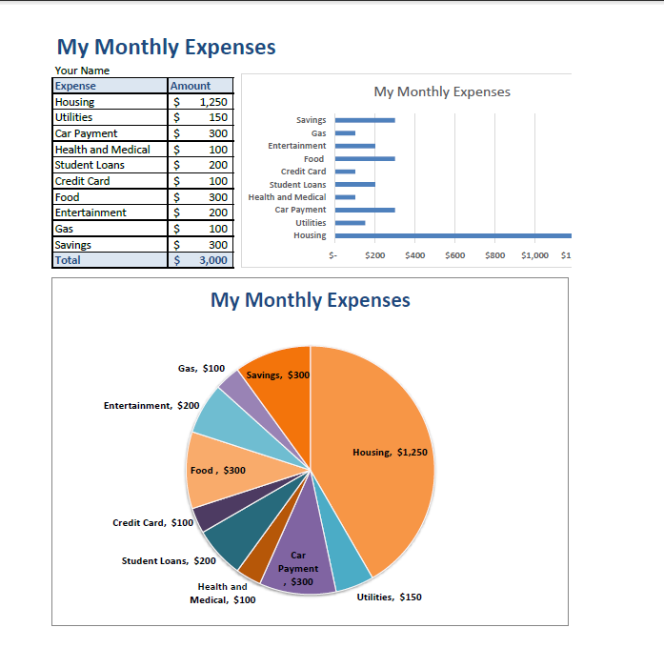

Visual Workshop

In this exercise, students create the worksheet and chart shown below using the skills learned in the unit.
- Company name in cell A1 (merged cell) is formatted as Calibri 18 pt. Worksheet title has 24 pt Impact font type applied (bold, Red Accent 2).
- Shading in A5:E5 and A11:E11 is Blue, Accent 1, Lighter 80%.
- Sparklines in F6:F11--Sparkline Style Dark #5 is applied.
- Bar chart formatting: Style 1 is applied; axis titles have the Intense Effect, Red Accent 2 shape style applied;
- Pie chart formatting: Style 11 is applied; Color 3 palette is applied, and labels formatted in Calibri 9 pt white bold.
Solutions should match the figure below exactly.

Filename: I-Volunteer Participation.xlsx

