Microsoft Office 2013 Illustrated
Unit L: Creating Database Reports
Table of Contents
Concepts Review 2
Skills Review 3
Independent Challenge 1 8
Independent Challenge 2 14
Independent Challenge 3 18
Independent Challenge 4: Explore 19
Visual Workshop 20

Unit L: Creating Database Reports

Concepts Review

Screen Labeling | Matching Items | Multiple Choice
1. Label button | 9. d | 13. d
2. Report title | 10. c | 14.b
3. YTD Orders field name/column heading in report | 11.a | 15. d
4. Field value for Canoe Country YTD Orders | 12. b | 16. a
5. Print Preview button
6. Design View button
7. Layout button
8. Report View button

Skills Review
The filename for the completed database in this exercise is L-Poster Business.accdb. The completed solution file contains the following reports: Poster Labels, Posters by Artist, Sanchez Sports Posters Sales. All objects in the database are shown in the Navigation pane below:
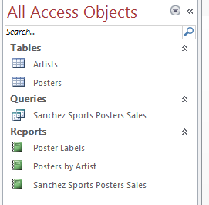

Estimated completion time: 30 minutes
Filename: L-Poster Business.accdb
Step 2d—Posters by Artist filtered report (should show only Melvin Cowens)
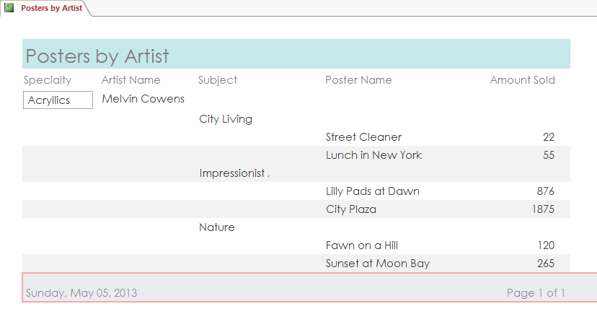

Step 5e—Posters by Artist report, page 1
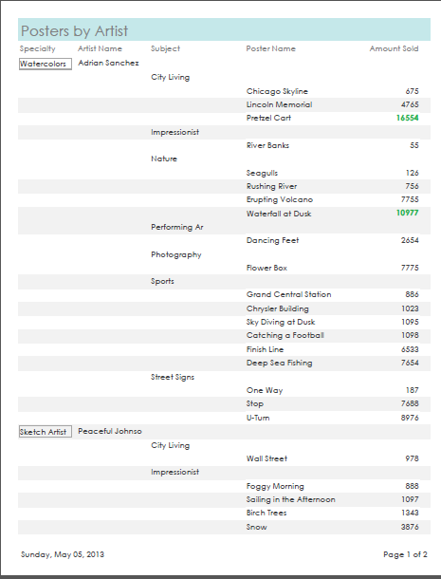

Step 5e—Posters by Artist report, page 2
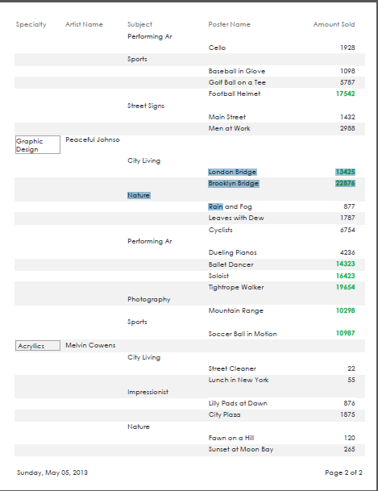

Step 6f, Sanchez Sports Posters Sales report (cropped; only top half of page is shown below)
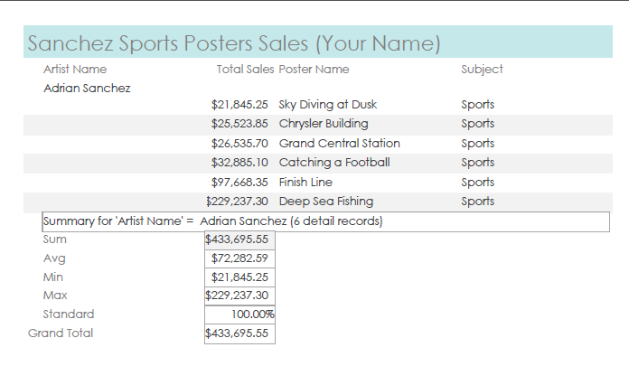

Step 7f, Poster Labels report, Page 1 of 1
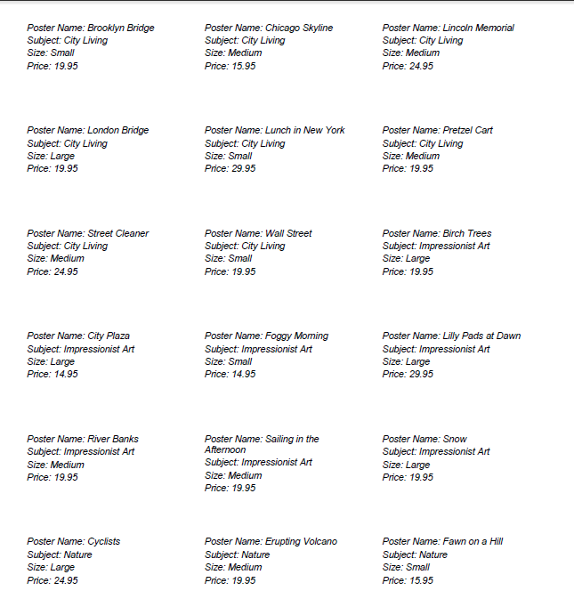

Independent Challenges
Because students may tackle the independent challenges in different ways, it is important to stress that for some Independent Challenges there is not just one correct solution.

Independent Challenge 1
Students work with an existing database that keeps track of campers, leaders, and programs for an arts camp. Students create a report named Campers by Specialty based on the Leaders and Campers tables. Students also create a report named Campers Labels. All solutions for these objects are shown below. Students’ solutions should match the solutions shown below exactly.

Estimated completion time: 30 minutes
Filename: L-Arts Camp

Step g, Campers By Specialty report—page 1 (This report has 3 pages—but page 2 contains no data. )
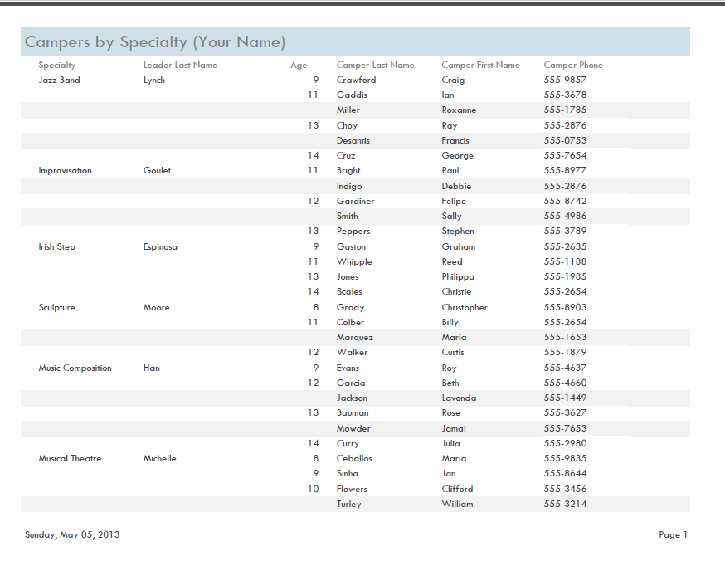

Step f, Campers by Specialty report—page 2
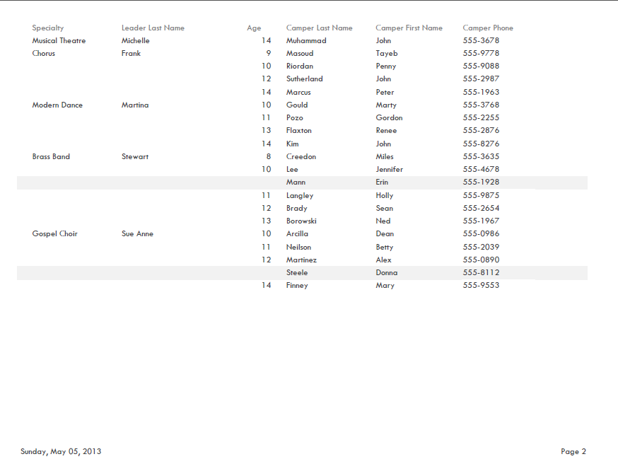

Campers Labels report, step f (page 1)
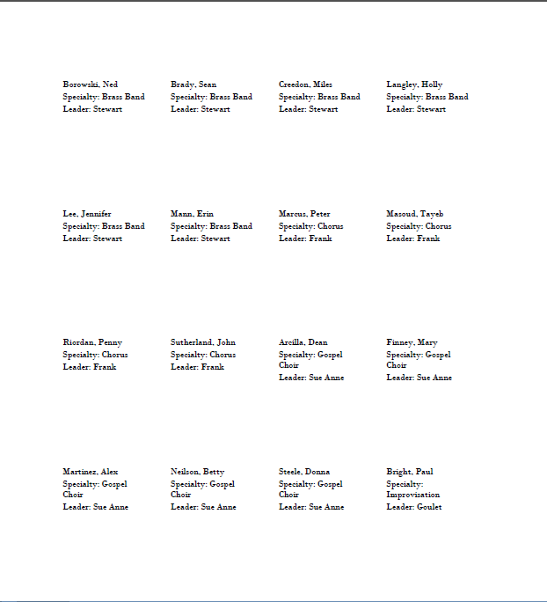

Campers Labels report, step f (page 2)
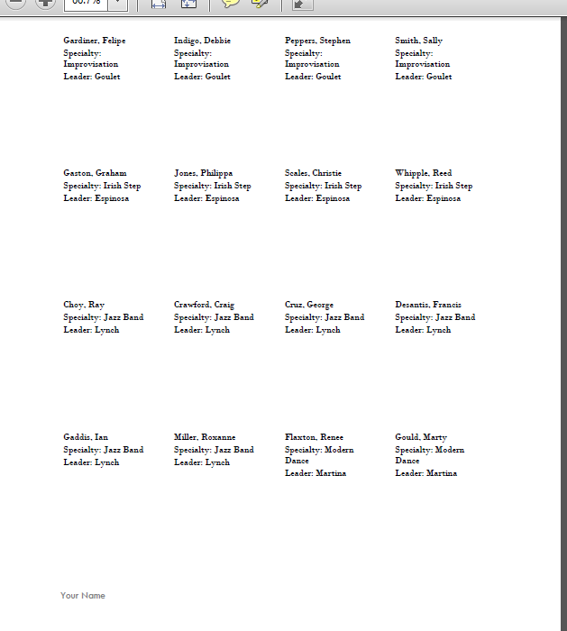

Campers Labels report, step f (page 3)
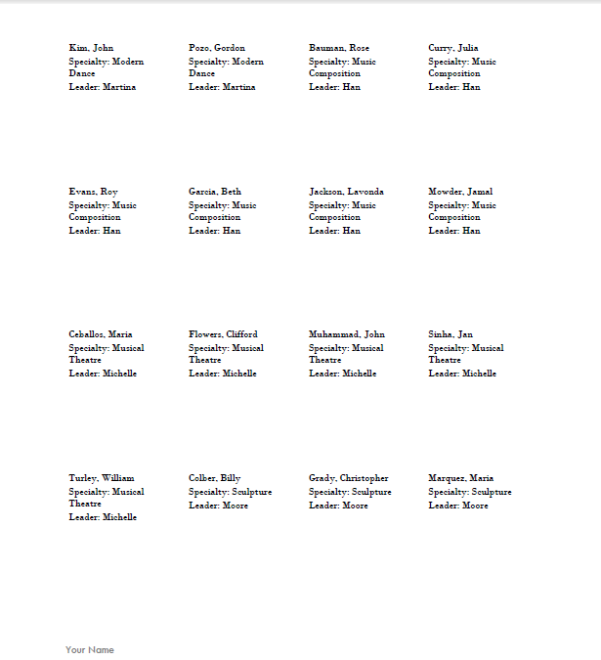

Campers Labels report, step f (page 4)

Independent Challenge 2
In this exercise, students work with a database for a fitness center that keeps track of its classes, students, and instructors. Students create a report named Students by Class based on the Classes and Students table.. Students also create a report named Classes Fees Due (Your Name). These reports should match the solutions shown below exactly.

Estimated completion time: 30 minutes
Filename: L-Fitness Center.accdb—Students by Class Report (2 pages)
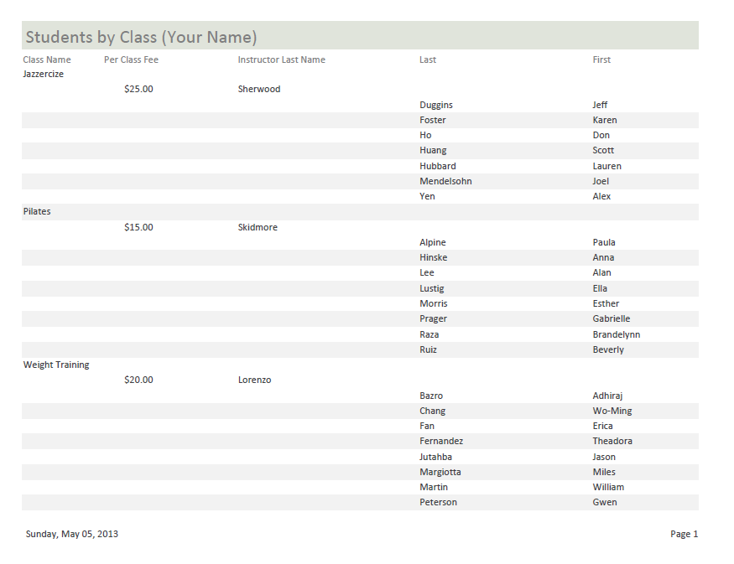
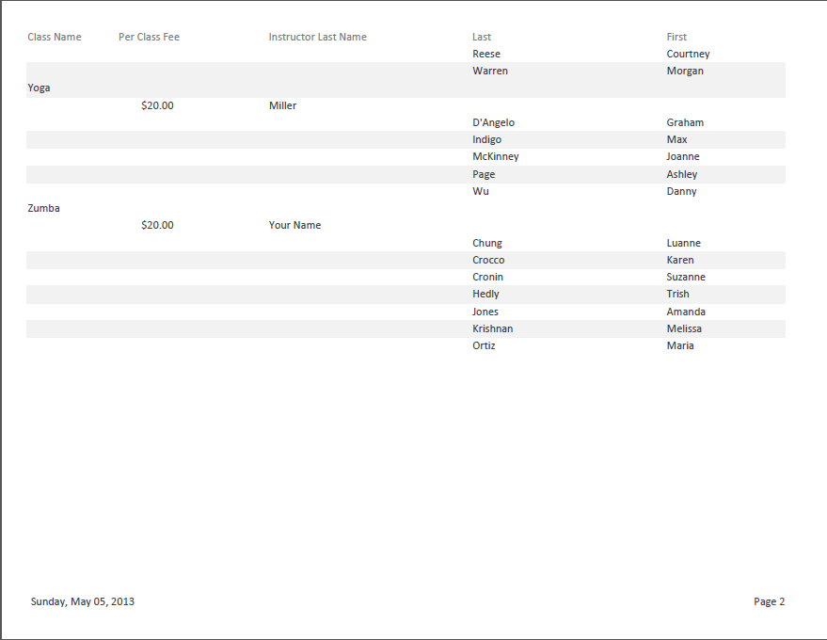
Filename: L-Fitness Center.accdb—Class Fees Due (Your Name)
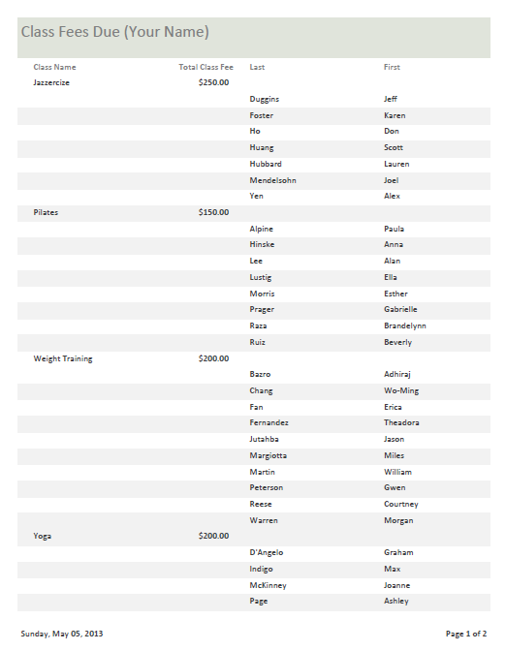

Filename: L-Fitness Center.accdb—Class Fees Due (Your Name), Page 2

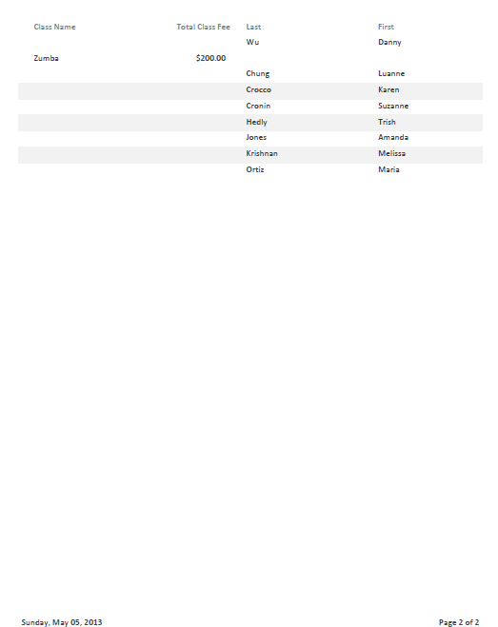

Independent Challenge 3
In this Independent Challenge, students work with the L-Uncle Ruff’s Dog Care database. Students create a report to track customer payments, and use conditional formatting to highlight premium customers who have spent more than $500 for the calendar year. Final reports should match the solution shown below.
Estimated completion time: 20 minutes
Filename: L-Uncle Ruff’s Dog Care.accdb—Customer YTD Payments report
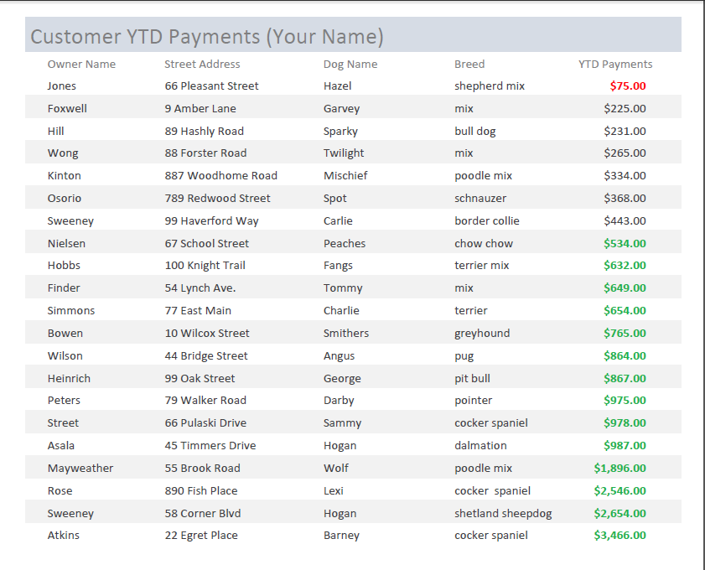

Independent Challenge 4: Explore
In this Independent Challenge, students create a report based on the tables in the L-My Classes.accdb database. (NOTE: If students completed the Independent Challenge 4: Explore exercise in Unit K, they can build from the database they worked with in that exercise—this will allow them to skip step c. ) Students create a report named My Class Schedule (your name) that includes fields from the Classes, Instructors, and Homework tables. Solutions will vary based on the information that they enter into the tables. However, the fields and order of the fields should match the solution below. Also, all field names and information should be visible in the report.
Estimated completion time: 45 minutes
Filename: L-My ClassesInformation.accdb--My Homework (Your Name) report
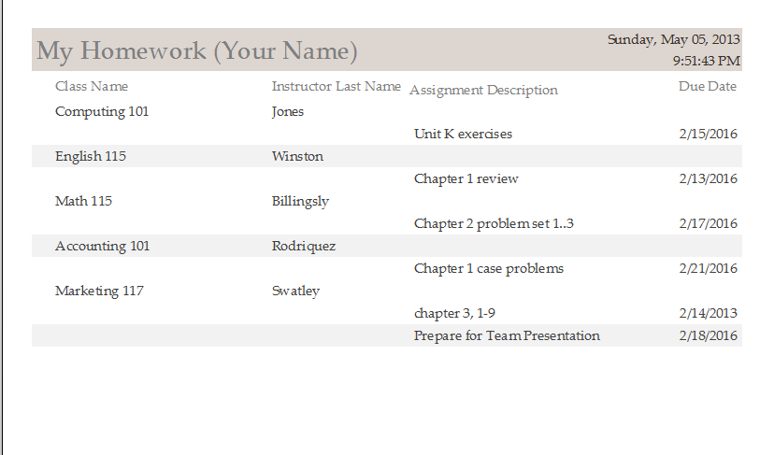

Visual Workshop
In this exercise, students need to create the report named United Way Donations based on the United Way Donations query in the L-Dance Charity Event.accdb file. Students’ solutions need to match the solutions shown below exactly. The grid theme should be applied.
Filename: L-Dance Charity Event.accdb —Donations report
