Microsoft Office 2013 Illustrated
Capstone Projects
Table of Contents
Word Project 1 2
Word Project 2 4
Excel Project 1 5
Excel Capstone Project 2 6
Access Capstone Project 2 11
PowerPoint Capstone Project 1 13
PowerPoint Capstone Project 2 14

Capstone Projects

Word Project 1
The filename for the completed document in this exercise is CS-Community Wellness Day Proposal.. The completed solution file is shown here.

Filename: CS-Community Wellness Day Proposal.docx—page 1
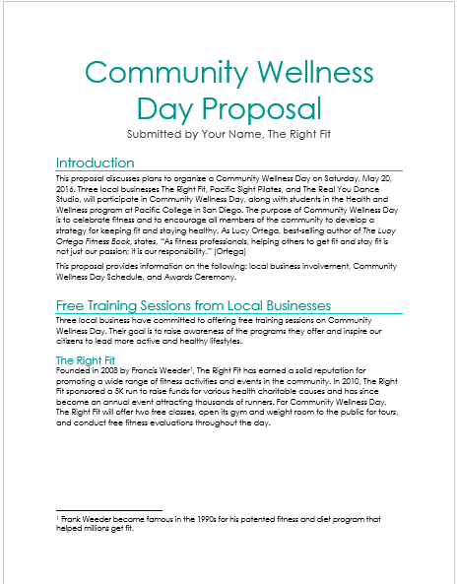

Filename: CS-Community Wellness Day Proposal.docx—page 1
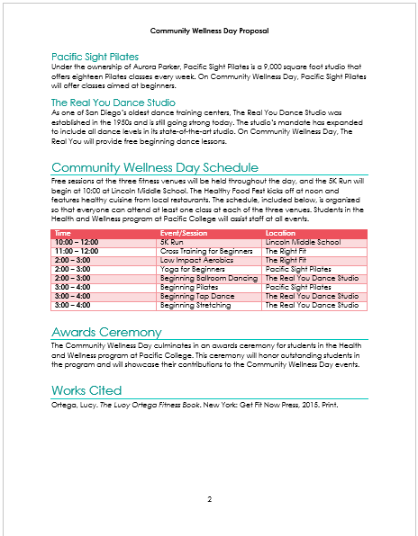

Word Project 2
The filename for the completed document in this exercise is CS-CS-Winter Fitness Schedule.docx.. The completed solution file is shown here.

Estimated completion time: 30 minutes

Filename: CS-Winter Fitness Schedule.docx

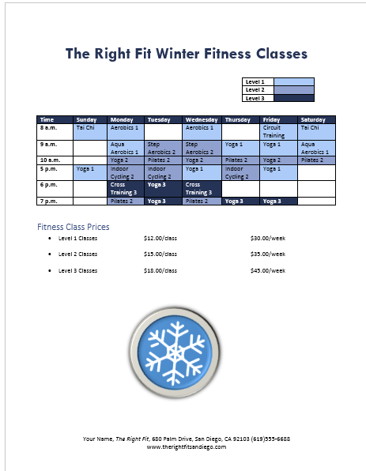

Excel Project 1
The filename for the completed workbook in this exercise is CS-Classes Sales Analysis.xlsx.. The completed solution file is shown here.

Estimated completion time: 20 minutes
Filename: CS-Classes Sales Analysis.xlsx (Sheet1)
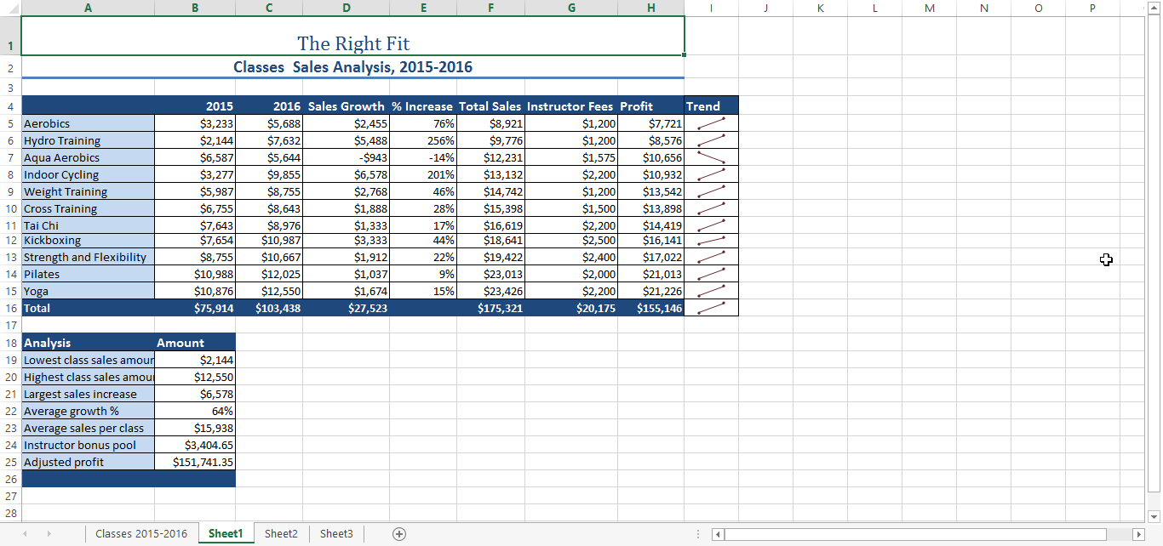

Filename: CS-Classes Sales Analysis.xlsx (Chart sheet Classes 2015-2016)
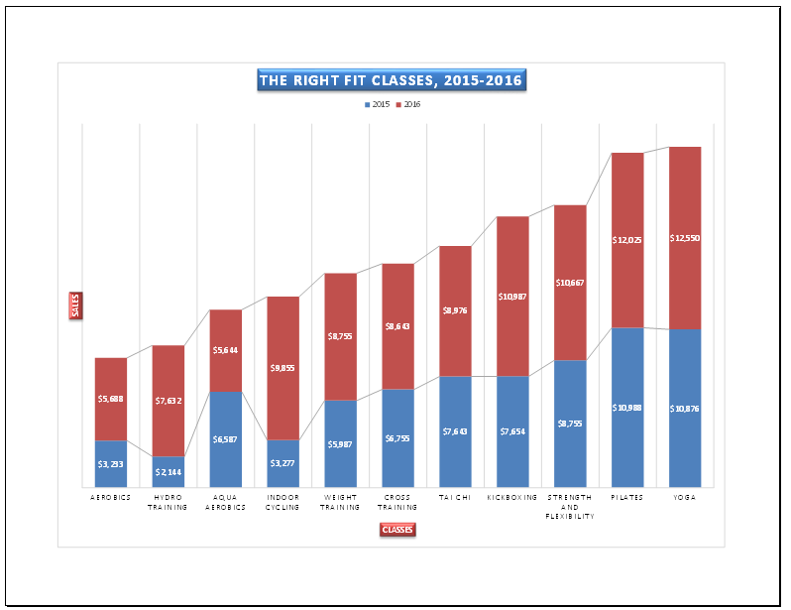

Excel Capstone Project 2

The filename for the completed workbook in this exercise is CS-5K Race.xlsx. The completed solution file is shown here. Student solutions should match the solution below exactly.

Estimated completion time: 20 minutes
Filename: CS-5k Race.xlsx—Budget worksheet and chart
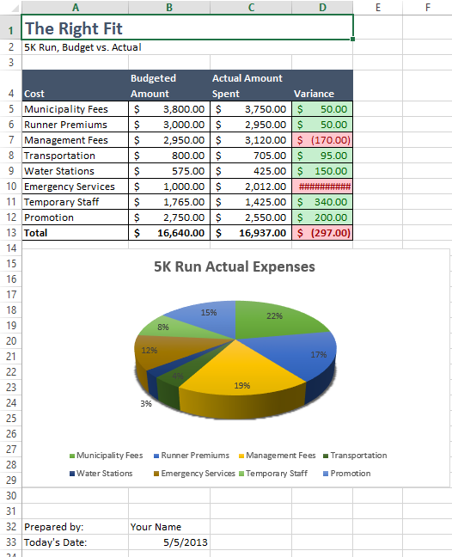

Filename: CS-5k Race.xlsx—Fundraisers sheet
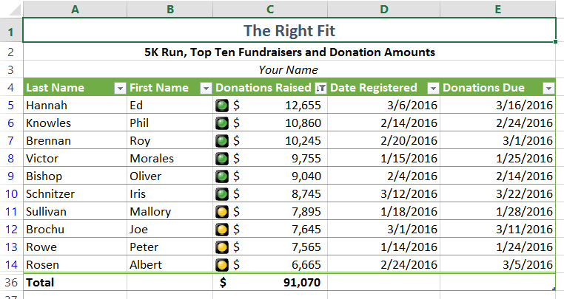
Access Capstone Project 1
The filename for the completed database in this exercise is CS-The Right Fit.accdb. All of the database objects that students need to create are shown in the Navigation pane below:

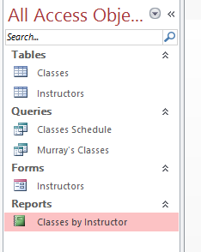
Estimated completion time: 20 minutes

Filename: The Right Fit.accdb—Classes table in Design view
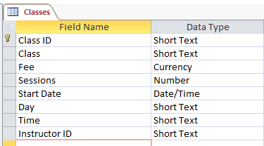

Filename: The Right Fit.accdb—Instructors table in Design view
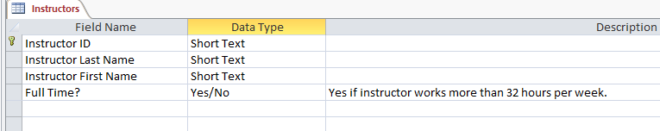

Filename: The Right Fit.accdb—Classes Schedule query
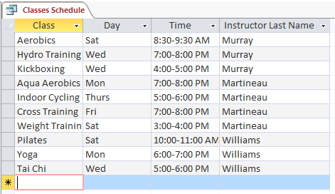
Filename: The Right Fit.accdb—Murray’s Schedule query

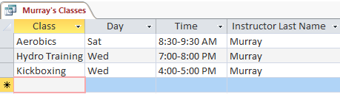
Filename: CS-The Right Fit.accdb—Instructor form

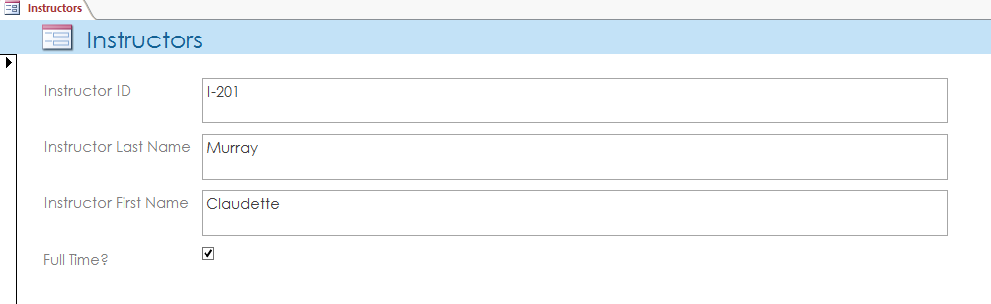

Filename: CS-The Right Fit.accdb—Classes by Instructor report
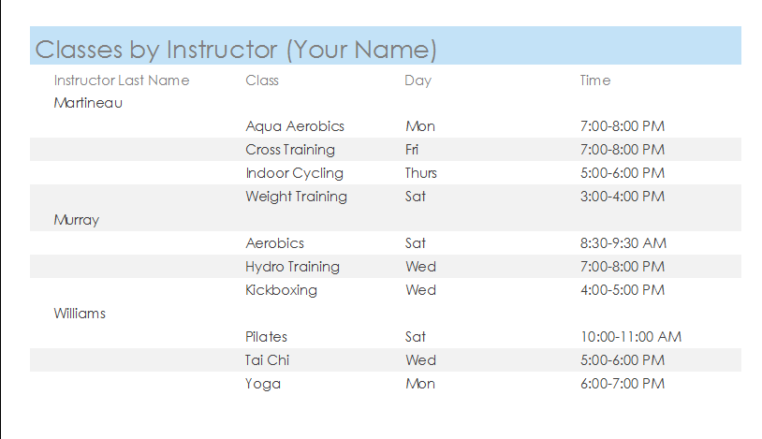

Access Capstone Project 2

The filename for the completed database in this exercise is CS-Community Wellness Day.accdb.

Estimated completion time: 20 minutes
Filename: Community Wellness Day.accdb—Event and Sponsors query

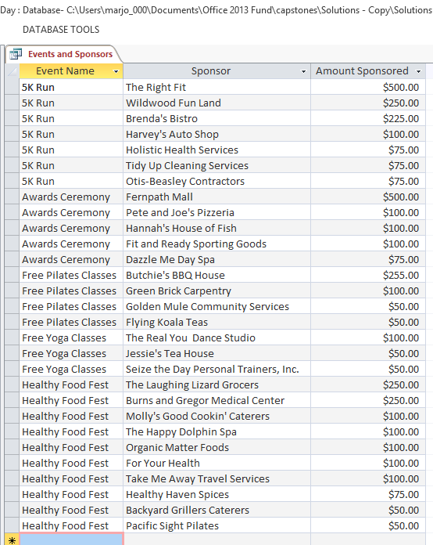

Filename: Community Wellness Day.accdb—Gold Sponsors query
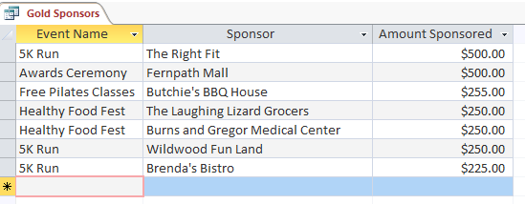

Filename: Community Wellness Day.accdb—Event and Sponsors (Your Name) report
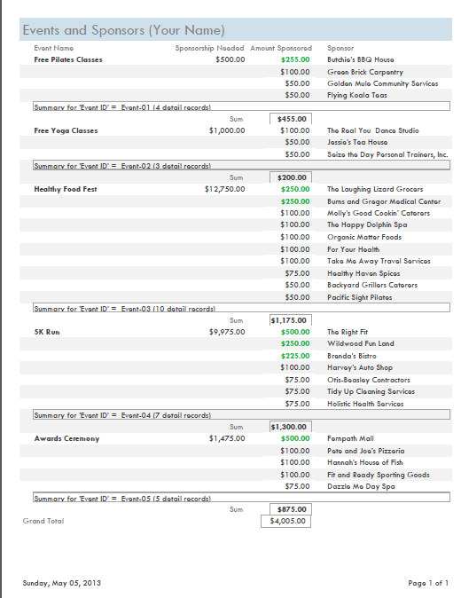

PowerPoint Capstone Project 1

The filename for the completed presentation in this exercise is CS-Company Overview.pptx.

Estimated completion time: 20 minutes
Filename: CS-Company Overview.pptx

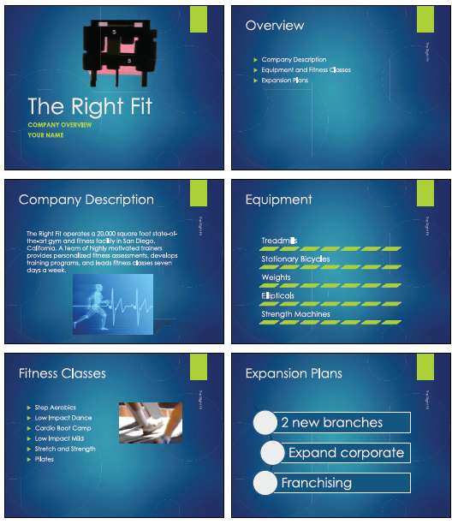

PowerPoint Capstone Project 2

The filename for the completed presentation in this exercise is CS-Staff Orientation.

Estimated completion time: 20 minutes
Filename: CS-Staff Orientation.pptx

