Microsoft Office 2013 Illustrated
UNIT J Creating a Database
Table of Contents
Concepts Review 2
Skills Review 3
Independent Challenge 1 5
Independent Challenge 2 7
Independent Challenge 3 8
Independent Challenge 4: Explore 10
Visual Workshop 12

Unit J: Creating a Database

Concepts Review

Screen Labeling | Matching Items | Multiple Choice
1. Navigation pane | 9. b | 15. c
2. Sales reps table | 10. f | 16. a
3. Navigation bar | 11. d | 17. a
4. Data Type list | 12. c | 18. c
5. President’s Club field in table | 13. b | 19.d
6. Record | 14. a | 20. a
7. Sales Reps table tab |  | 21. c
8. Shutter Bar Open/Close button |  | 22. a

Skills Review

- Understand Databases--solutions
- Explain the purpose of Microsoft Access; what type of business tasks is it designed to perform?
Answer: Microsoft Access is a database program used to help you manage and track a large collection of related data. Examples of business tasks include: manage inventory, manage information about products or employees; store financial data.
- Definitions
Database-an organized collection of related information.
Table- a collection of related records, organized in a gridlike format with rows (records) and columns (fields).
Field- A specific category of information in a database such as name, address, or phone number. Usually organized in the smallest possible unit to facilitate organization, such as last name and first name. in a table, a field ontain information a
Record—a row in a table that contains all related information for one entry
Form-- A database object that is used to enter, edit, or display records in a
database one at a time.
Report- A summary of database information designed specifically for printing.
Queries- A database object that extracts data from one or more tablesin a database according to set criteria.
- What are the database objects in Access/purpose of each:
Table-a collection of data organized in rows (records) and columns
Form-A window that lets you view, enter and edit data in a database one record at a time.
Report- A summary of database information designed specifically for printing
Query-a set of criteria you specify to retrieve data from a database
In steps 2-8, students create a database from scratch for a party rental business. The objects they create are shown below

Filename: J- Party Equipment Rentals.accdb—Bounce Houses table in Datasheet view
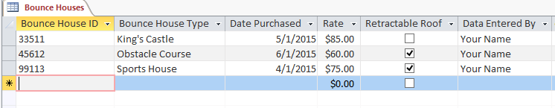

Filename: J- Party Equipment Rentals.accdb—Bounce Houses table in Design view
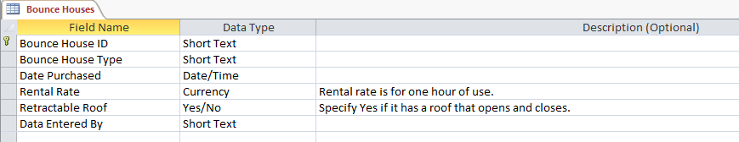

Filename: J- Party Equipment Rentals.accdb—Rental Orders table in Datasheet view
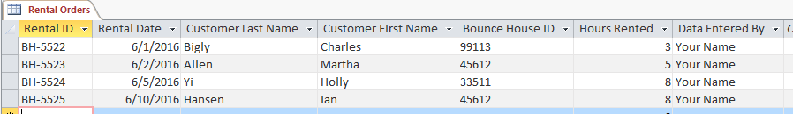

Filename: J- Party Equipment Rentals.accdb—Rental Orders table in Design view
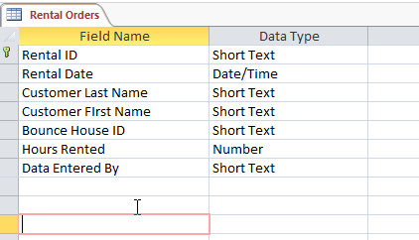

Filename: J- Party Equipment Rentals.accdb—Rental Orders form
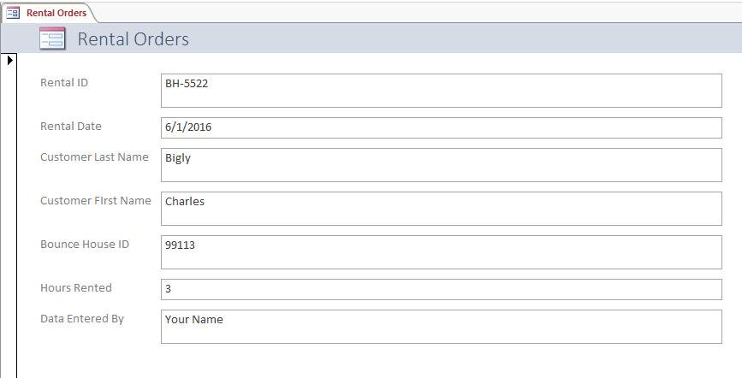

Independent Challenges

Because students may tackle the independent challenges in different ways, it is important to stress that for some Independent Challenges there is not just one correct solution.

Independent Challenge 1
Students create a database to keep track of props for a community theatre company. Students create a table named Props, a table named Prop Suppliers and a form named Props Form. All objects are shown below.

Estimated completion time: 30 minutes
Filename: J-Loud Voice Theatre.accdb

Filename: J-Loud Voice Theatre.accdb —Props table, Design view
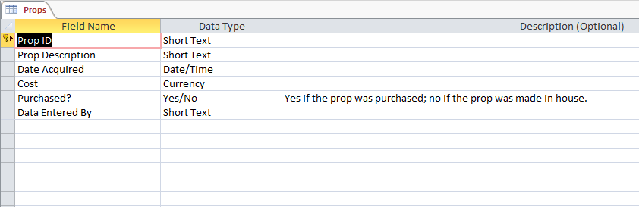

Filename: J-Loud Voice Theatre.accdb —Props table, Datasheet view
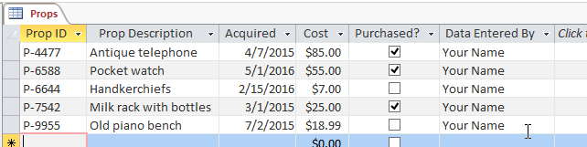
Filename: J-Loud Voice Theatre.accdb —Prop Suppliers table, Datasheet view

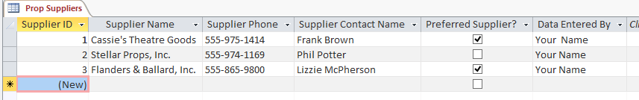
Filename: J-Loud Voice Theatre.accdb —Prop Suppliers table, Design view
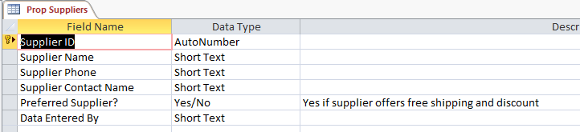

Filename: J-Loud Voice Theatre.accdb —Prop form (cropped on right)
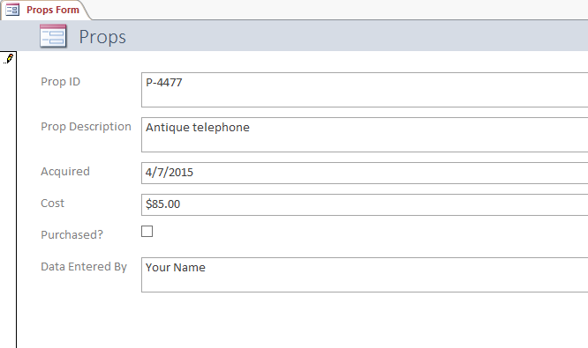

Independent Challenge 2
In this exercise, students create a database to keep track of costume inventory. Students create a table named Costumes and a form named Costumes. Both are shown below.

Estimated completion time: 20 minutes
Filename: J-Costume Rentals.accdb

Filename: J-Costume Rentals.accdb —Costumes table in Datasheet view
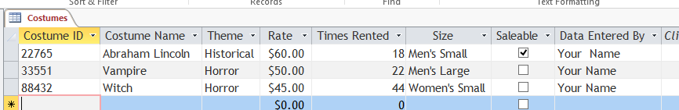
Filename: J-Costume Rentals.accdb —Costumes table in Design view
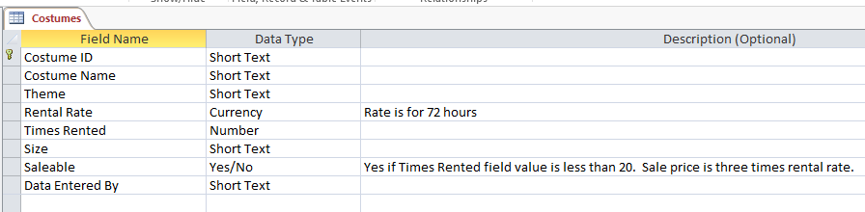

Filename: J-Costume Rentals.accdb —Costumes form
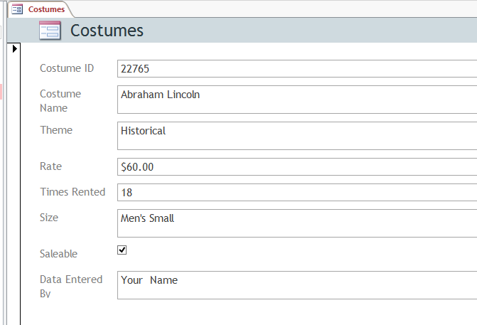

Independent Challenge 3
In this Independent Challenge, students create a database to keep track of past participants at Red Onion Cooking School. Students’ solutions will vary in form and content. Look for the following elements in each solution:

- The database should be called J-Cooking School.accdb and should contain a table named Students and a form named Students.
- The table should contain at least seven fields. One field must have the Date/Time field type applied to it, and another field must have the Yes/No field type applied to it.
- The table must include these three fields: First Name, Last Name, and Data Entered By.
- One of the fields needs to be assigned the primary key field.
- The form can have any theme applied to it that the student chooses.
- There should be three records in the table.

Estimated completion time: 20 minutes
Filename: J-Cooking School.accdb

Filename: J-Cooking School.accdb—Students table, in Datasheet view (This is one possible solution; solutions will vary)

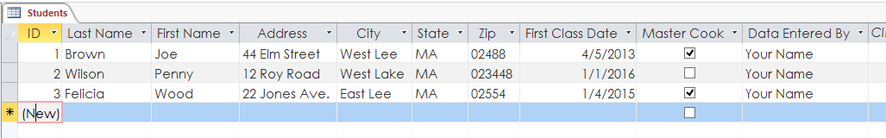

Filename: J-Cooking School.accdb—Students table, in Design view (This is one possible solution; solutions will vary)
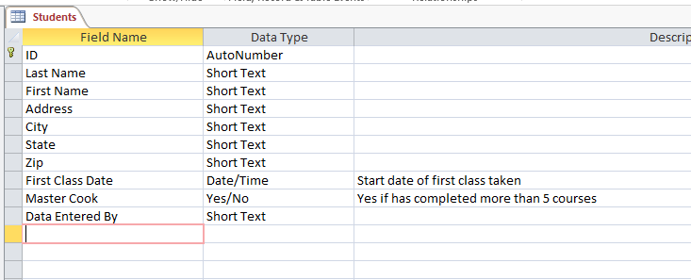

Filename: J-Cooking School accdb—Students form (This is one possible solution; solutions will vary)
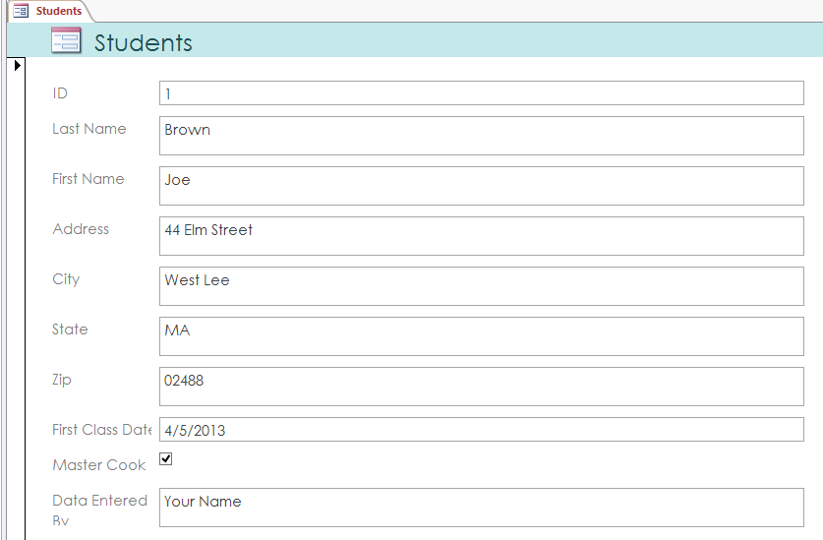

Independent Challenge 4: Explore
In this Independent Challenge, students create their own contacts database based on a template. Note: students will need an internet connection to complete this exercise.

- The solution is shown below.

Estimated completion time: 20 minutes
Filename: J-Contacts.accdb

Filename: J-Contacts.accdb—Contact Details form
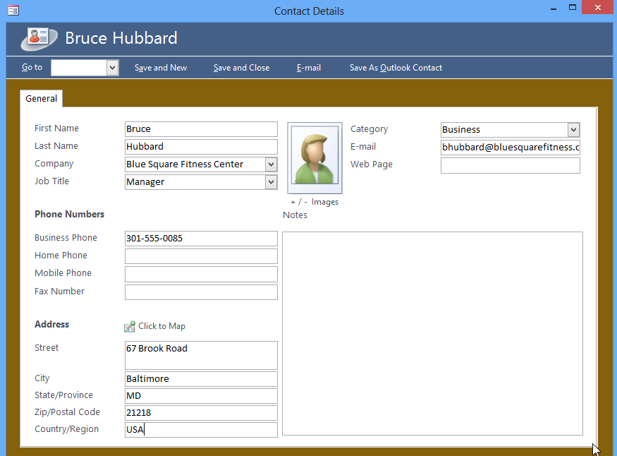

Filename: J-Contacts.accdb— Contacts table with 3 records entered (right side is cut off)

Filename: J-Contacts; Phone book with three records added
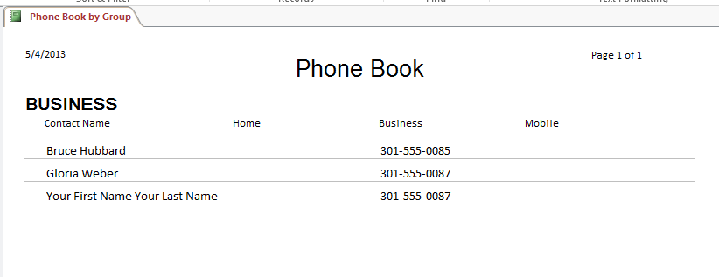
Filenme: J-Contacts; Directory with three records added
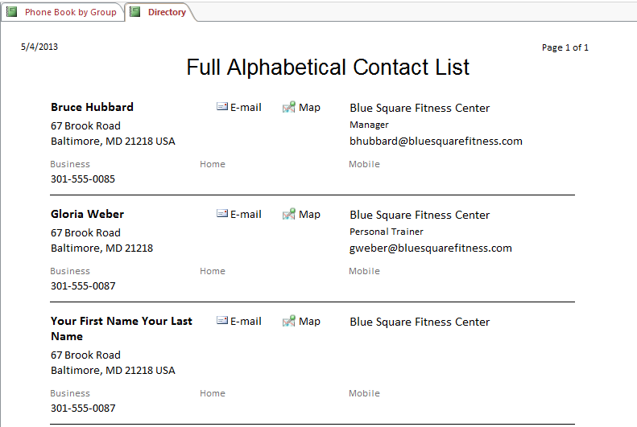

Visual Workshop

In this exercise, students create a database named J-Car SalesBusiness.accdb. Within this database, they create a table named Cars and a form named Cars.. Students’ solutions need to match the solution shown below exactly. (Suggestion: instruct students to create a screen capture of their screens using the screen shot tool in Word.)

Estimated time to complete: 30 minutes
Filename: J-Car Sales Business.accdb

Filename: J-Car Sales Business.accdb—Cars table

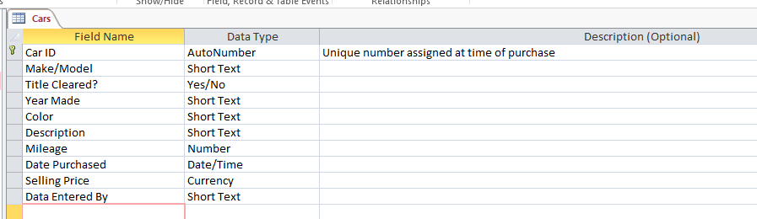
Filename: J-Car Sales Business.accdb—Cars form
