Microsoft Office 2013 Illustrated
UNIT G: Creating and Enhancing a Worksheet
Table of Contents
Concepts Review 3
Skills Review 4
Independent Challenge 1 5
Independent Challenge 2 6
Independent Challenge 3 7
Independent Challenge 4: Explore 9
Visual Workshop 10

Unit G: Creating and Enhancing a Worksheet

Concepts Review

Screen Labeling | Matching Items | Multiple Choice
1. Name box | 13. f | 19.c
2. Enter button | 14. b | 20. a
3. Formula bar | 15. c | 21. c
4. Row selector buttons | 16. e | 22. b
5. Sheet tabs | 17. a | 23. a
6. New Sheet button | 18. d
7. Active cell
8. Column headings
9. Decrease Decimal button
10. Comma Style button
11.Number Format list arrow
12. Accounting Number Format button

Skills Review
The filename for the completed workbook in this exercise is G-December Sales.xlsx. The completed solution file is shown here. Note that the date in the student’s footers should reflect the current date.

Filename: G-December Sales.xlsx (close up view of data)

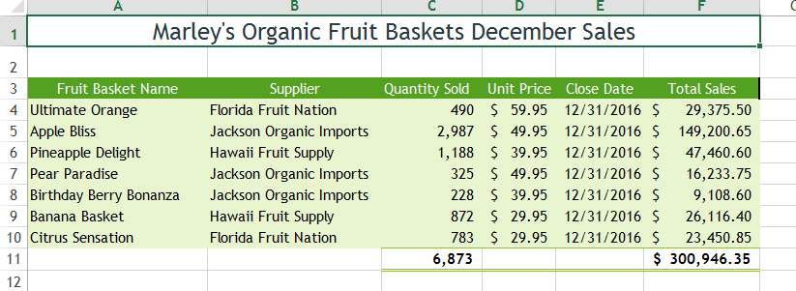
Filename: G-December Sales.xlsx (in Print Preview—showing footer)
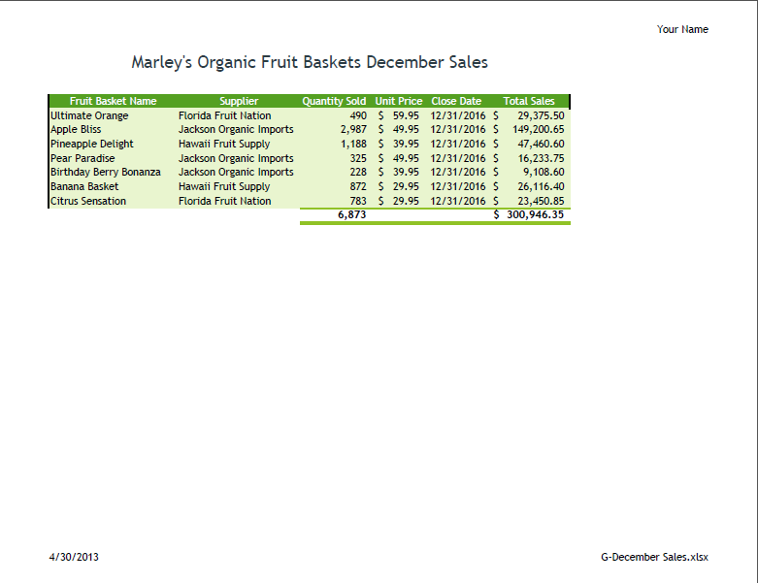

Independent Challenges
Because students may tackle the Independent Challenges in different ways, it is important to stress that for some Independent Challenges there is not just one correct solution.

Independent Challenge 1
Students create a new workbook and enter specified information into cells. They enter formulas, format cells, and add a header, and apply the Solstice theme. Solutions should match the solution below.

Estimated completion time: 20 minutes
Filename: G-Top June Orders.xlsx (up close view in Normal view)
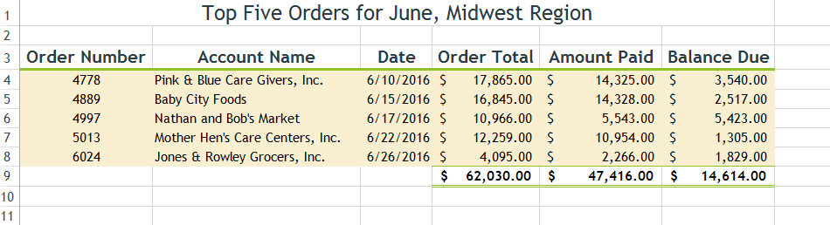

Filename: G-Top June Orders.xlsx (in Print Preview))
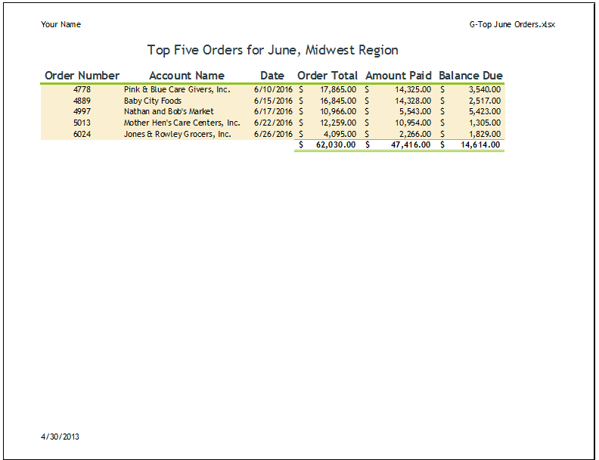

Independent Challenge 2
In this exercise, students create a new worksheet that analyzes sales of a craft business which has 5 stores in the Midwest. The purpose of the worksheet is to compare July sales at each store to the prior month (June). They also compare actual July sales to the forecast. Students enter data, labels, and formulas, apply conditional formatting and format the worksheet, and add their names to the header. Students’ solutions should contain the same content and formulas, but will be formatted differently (they can choose any theme they want). One possible solution is shown below.

Note: if you are using the first printing of the book, please be aware that the introductory paragraph has some inconsistencies in it, which will be fixed in subsequent printings. The corrections made are shown here:

You are the franchise manager for Blackford & Wickes Crafters a new specialty store business with five craft stores n the Midwest. You need to create a worksheet that analyzes first quarter July sales by store. Your worksheet needs to compare third quarter July sales of each store to the previous quarter month (June). You also want the worksheet to show how third quarter July actual sales compare to the third quarter July sales forecast. Because it is a new, growing business, each store was forecast to meet a sales increase of 5% over the prior quarter month.

Estimated completion time: 20 minutes
Filename: G-Sales Analysis.xlsx
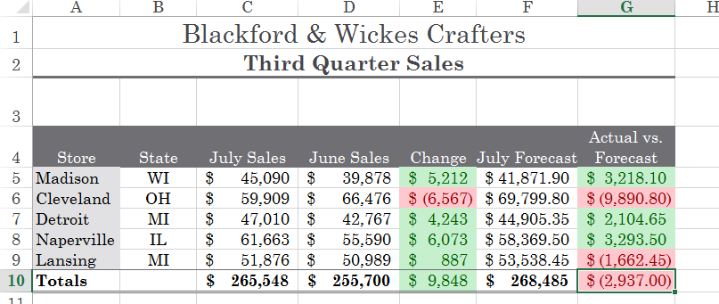

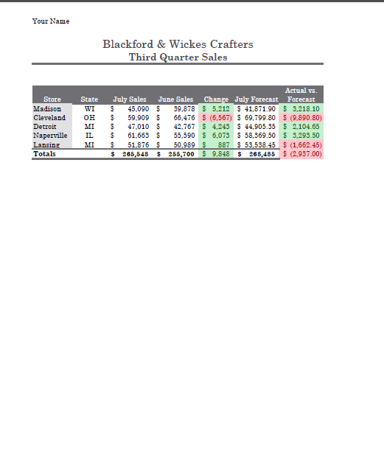
Independent Challenge 3
In this Independent Challenge, students create a new worksheet that calculates profits for used car business. Students are instructed to enter specific data, labels and formulas in specific cells. Students’ solutions will vary in formatting. Student solutions should also have the student’s name in the header.

Estimated completion time: 20 minutes

Filename: G-Car Profits.xlsx (up close look in Normal view)
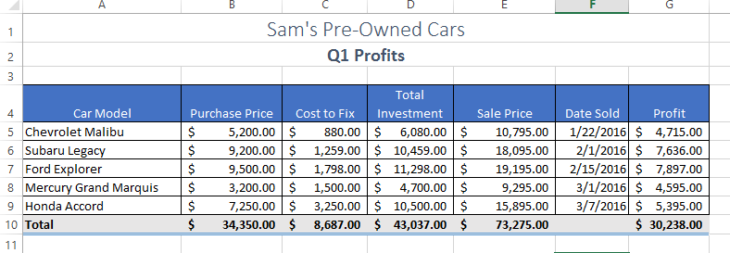

Filename: G-Car Profits.xlsx (full page view, in Print Preview)

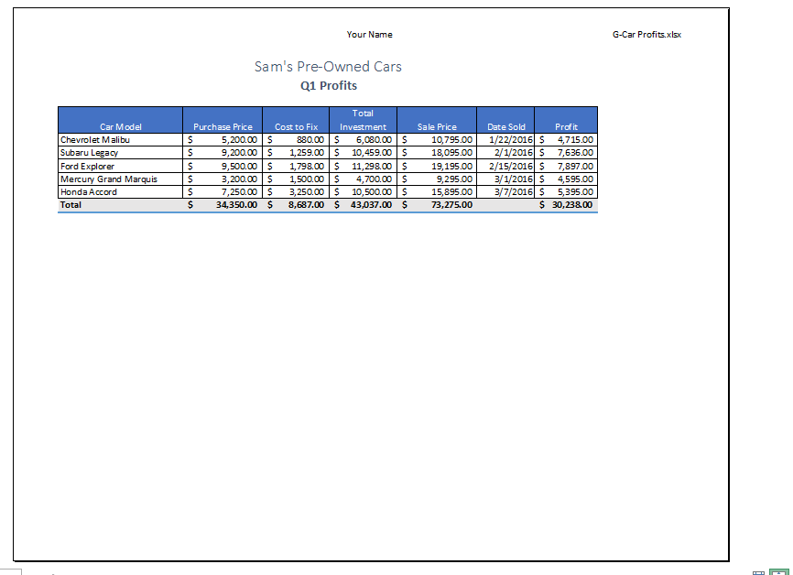

Independent Challenge 4: Explore
In this Independent Challenge, students create a worksheet that compares the cost of living in a new apartment to their current apartment costs. Actual data is provided in the exercise, so the solutions should contain the same data shown in the solution below. However, solutions will vary from student to student in content and format. Look for the following in each solution:

Filename: G-My New Budget.xlsx (Student solutions will be formatted differently, but the formulas and data should match the solution.)
Estimated completion time: 30 minutes

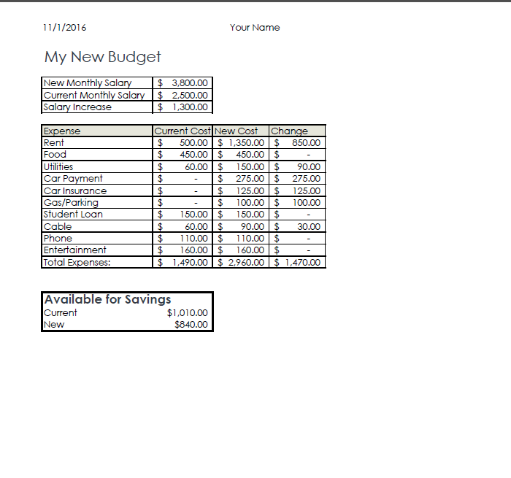

Visual Workshop

In this exercise, students create the worksheet shown below using the commands, formulas, and formatting skills learned in the unit. Solutions should match the figure below exactly. Instructions on how to rotate the labels in column A are provided in the assignment instruction paragraph (they should have fun with this!). Formatting in this solution is as follows: Shading: Orange, Accent 1; theme applied: Wood Type. Fonts: Rockwell Condensed for cell A1 Rockwell for all other cells.

Filename: G-Holiday Sales Summary.xlsx (up close in Normal view)
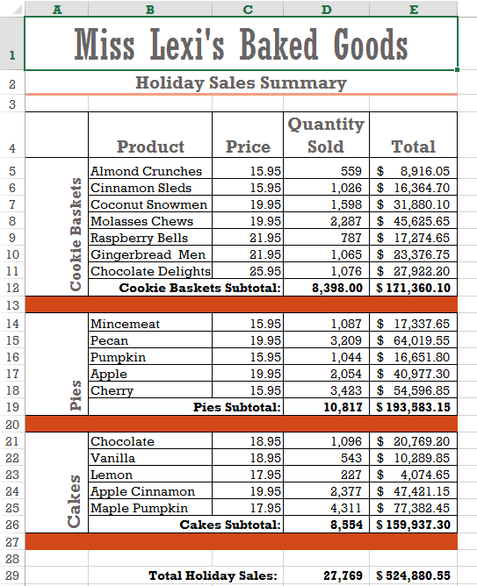

Filename: G-Holiday Sales Summary.xlsx (full page in Print Preview)
