Microsoft Office 2013 Illustrated
Unit F: Adding Special Elements to a Document
Table of Contents
Concepts Review 2
Skills Review 3
Independent Challenge 1 6
Independent Challenge 2 7
Independent Challenge 3 8
Independent Challenge 4: Explore 9
Visual Workshop 14

Unit F: Adding Special Elements to a Document

Concepts Review

Screen Labeling | Multiple Choice Questions
1. Navigation Pane | 10. c
2. Green Team heading in Navigation Pane | 11. a
3. Table | 12. b
4. End of cell mark | 13. d
5. Shading button list arrow | 14. c
6. Borders button list arrow | 15. a
7. sizing handle on selected image
8. Layout Options button
9. Picture Tools Format tab

Skills Review
The filename for the completed document in this exercise is F-New Report.docx. The completed solution file for all three pages is shown here. Note that the date in the footer of the report should show the current date.

Filename: F-New Zealand Report.docx (page 1)
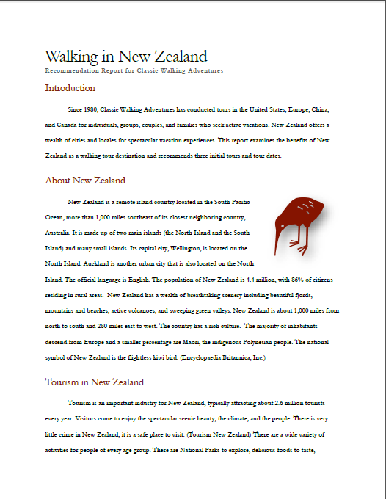

Filename: F-New Zealand Report.docx (page 2)

Filename: F-New Zealand Report.docx (page 3)

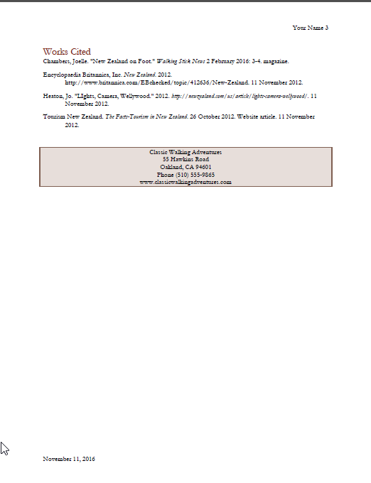

Independent Challenges

Because students may tackle the Independent Challenges in different ways, it is important to stress that there is more than one possible correct solution for some of these exercises.

Independent Challenge 1
Students open an existing document and apply formatting to it to make it attractive and easy to use. They also insert and format a table, and add clip art. Solutions should match the solution below except that they can use any appropriate clip art object that they want.

Estimated completion time: 20 minutes
Filename: F-Painted Dog Info Sheet.docx

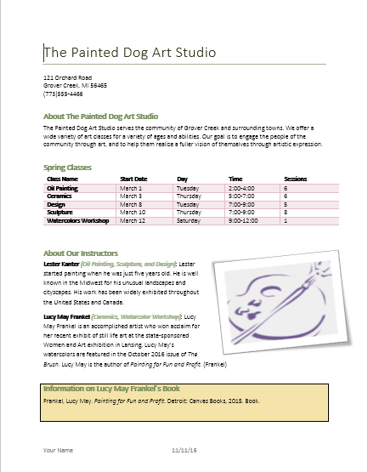

Independent Challenge 2
In this exercise, students open a copy of an existing unformatted document and enhance it by adding a table and clip art to it. Student solutions will vary because they have freedom to make their own formatting decisions. Look for the following in each solution:
- The table should appear below the first paragraph and should be formatted using a Table Style.
- The table should have a total of seven rows
- The column widths of the table should be adjusted so that the text in each row fits on one line
- The Our Mission Statement heading and paragraph should appear in a box with shading applied to it
- All text should be formatted attractively
- The document should contain a footnote reference mark next to Ravi Banarjee’s name
- The document should have a theme applied to it
- Students’ names should appear in the footer, right aligned.
One possible solution is shown below.

Estimated completion time: 20 minutes
Filename: F-First Day Schedule.docx

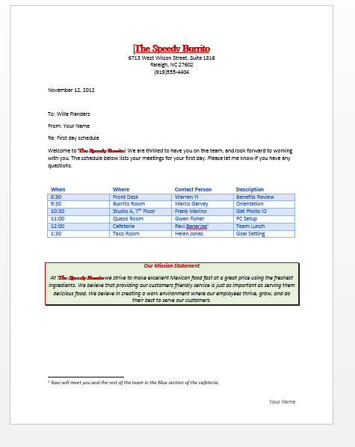

Independent Challenge 3
In this Independent Challenge, students use their creativity and formatting skills to create a one-page flyer announcing a Community Outreach Day Event. Solutions will vary in content and formatting. Look for the following in each solution:
  - Students can format the document however they wish using fonts, styles, font sizes, of their choosing. However, the finished document should reflect a casual, fun style.
  - The first line of the document should have shading applied to it.
  - The flyer should contain a table that includes the information specified, and the table should be formatted using any Table Style
  - The flyer should contain one piece of clip art
  - The student’s name should appear in the footer, centered.
  - A theme should be applied to the document.

Estimated completion time: 20 minutes
Filename: F-Outreach Day Events.docx

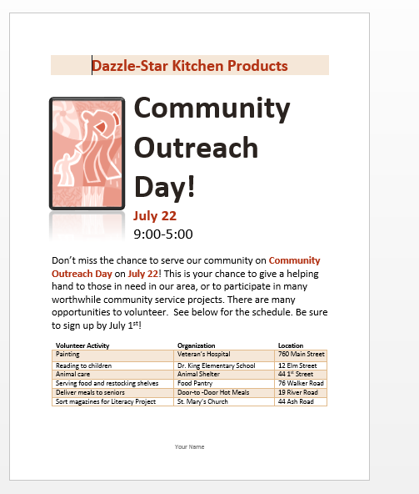

Independent Challenge 4: Explore
In this Independent Challenge, students open a document that contains text for a research paper then format it according to MLA standards. Before completing this lesson, instruct your students to review the lesson Formatting a Research paper on pages 168-169 of the text; this lesson provides steps on how to format a research paper, and it also shows the completed solution for this exercise that they can use as a visual aid. (If you need your students to learn APA format, you can download an APA version of the Formatting a Research Paper lesson from the Instructor Resource site for this book.

Each page of the finished research paper is shown below.

Filename: F-RFID Research Paper.docx
Estimated completion time: 30 minutes

Filename: F-RFID nResearch Paper.docx (page 1)

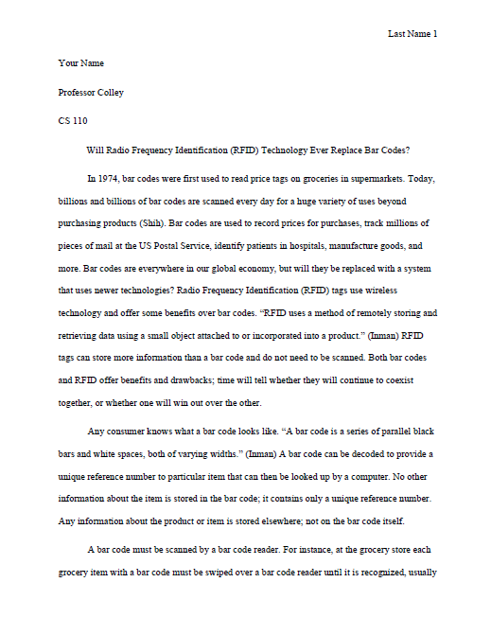

Filename: F-RFID Research Paper.docx (page 2)

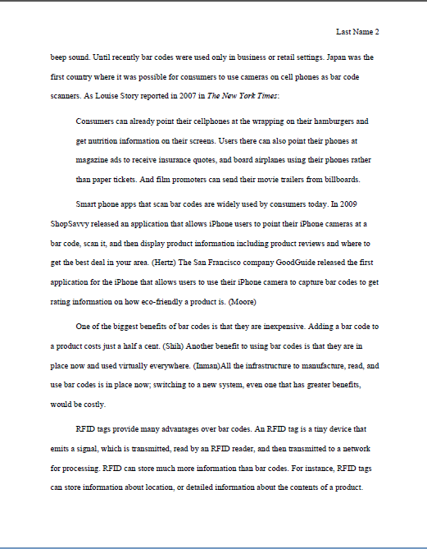

Filename: F-RFID Research Paper.docx (page 3)

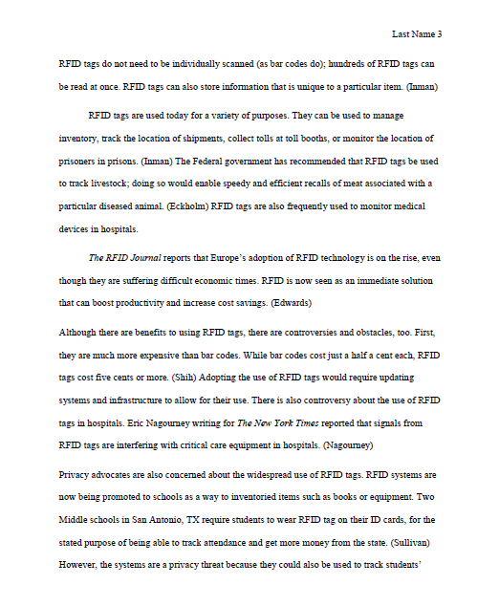

Filename: F-RFID Research Paper.docx (page 4)

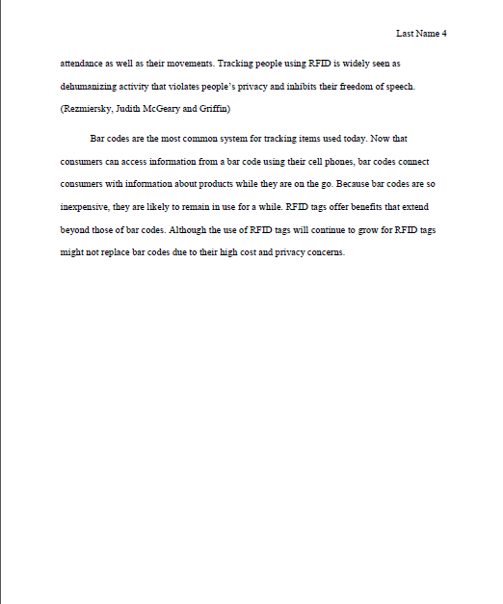

Filename: F-RFID Research Paper.docx (page 5)
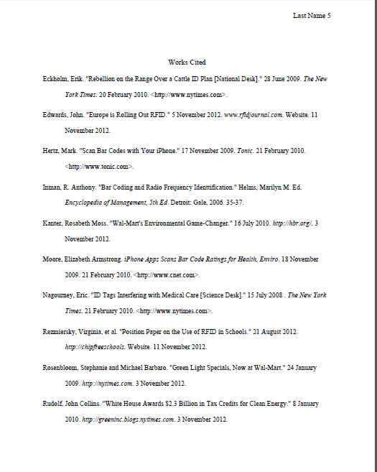

Visual Workshop

In this exercise, students format an existing document so that it appears as shown below. All solutions should match the one shown below. Here’s what to look for in students’ solutions:
- Metropolitan theme is applied. Blue Warm theme colors are applied.
- Line 1 of the document has the Title style applied
Paragraph is formatted using Calibri (Light) font (14 pt). Beach photo is inserted Office online clipart) text wrapping is set to Tight. The Bevel Perspective picture style is applied to the photo.
- Table has the List Table 2-Accent 2 Table style applied to it.
- Shading at bottom of document: Teal Accent 5, Lighter 80%
- Page border is applied (Blue Gray Accent 1) around entire page.
- Students’ names should be centered at the bottom of the document

Estimated time to complete: 30 minutes
Filename: F-Condo Rental Ad.docx

